

DaaS 3.0
Administrator Quick Reference Guide

989 Old Eagle School Road | Wayne, PA 19087 | 610.964.8000 | support@evolveip.net | www.evolveip.net
Contents
Getting Started 3
Main Menu 3
Active Directory Preparation 4
Domain Registration 6
Configuration 6
Deploying Desktops 7
Adding a User to the Desktop 9
Editing Desktop Assignments 11
Editing a Desktop Assignment to add more desktops 11
Creating a New Assignment (Pool) of Desktops 12
Deleting Desktops, Assignments and Images 13
Monitoring 14
View system or user activity for desktops and application assignments. 14

Getting Started
This guide overviews the general components of your DaaS environment. For the complete administrator guide that provides in-depth documentation for all setup, configuration, and features of DaaS 3.0 see the Additional Help section at the bottom of this document.

Main Menu
The Main Menu contains all the options to configure and monitor your environment. The main menu is divided into the following sections:
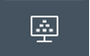
Dashboard- This tile provides the at-a glance overview of the desktop Connections, the Connection State and the Capacity Allocation of your deployed desktops.

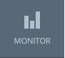
Monitor- This tile provides the dashboard view of the environment, an activity view that displays the last 24 or 48 hours, the previous week, and the previous 30 days of activity for Admin and Users alike.

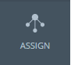
Assign- This tile is where you assign or place your new desktops into users and groups. For instance, a new helpdesk user can be placed into a helpdesk group within this section.

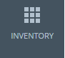
Inventory- This tile lists the Applications and Images available for your desktops. Your Preloaded Evolve IP desktop image will appear in this section.

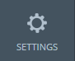
Settings- This tile provides the General Settings, Active Directory, Roles and Permissions, Locations, Getting Started, Utility VMs, and 2 Factor Authentication Settings for your organization.
There is a green play button located at the top right of the Settings page (see image below). The Getting Started tool provides an overview of the DaaS setup processes that you will need to complete and allows you to visualize your setup progress. Getting Started can also be reached from within the Settings tile.
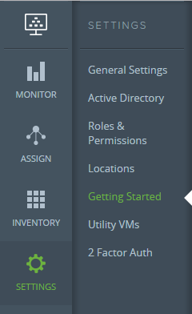

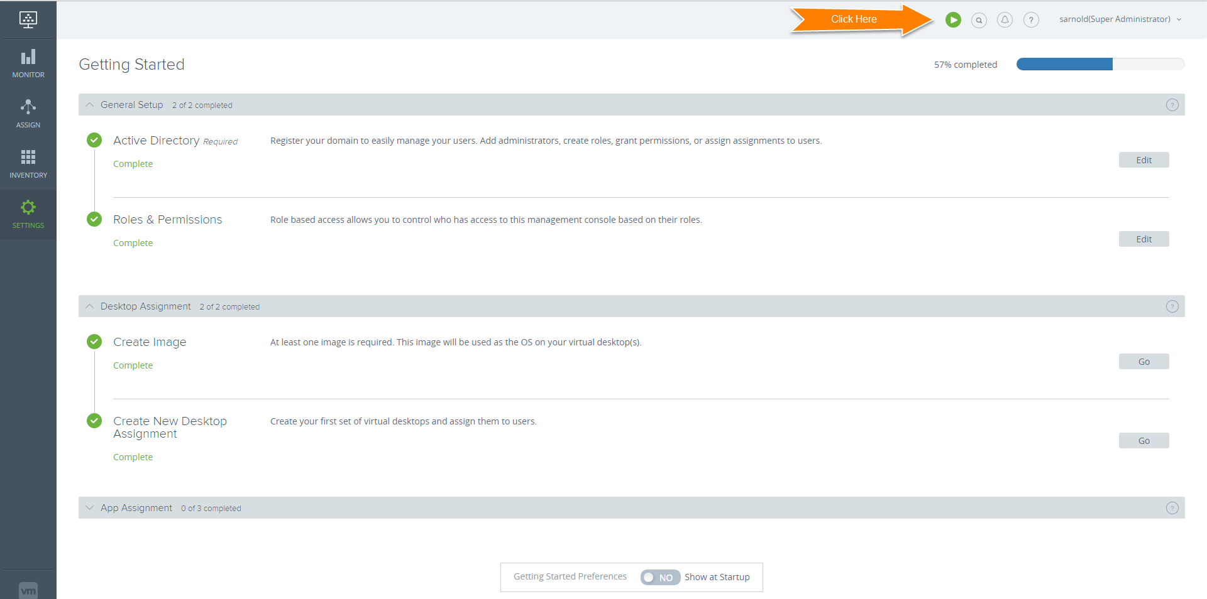

Active Directory Preparation
Authentication in the Evolve IP DaaS product is handled via Microsoft Active Directory. There are two accounts that need to be configured prior to the DaaS install. First, an LDAP bind account / service account is required for read only access to the AD. Second, a domain join account should be setup to automatically join new DaaS desktops to your corporate domain. Questions about this process can be discussed during the DaaS Implementation process. Go to SettingsActive Directory to access this configuration screen.
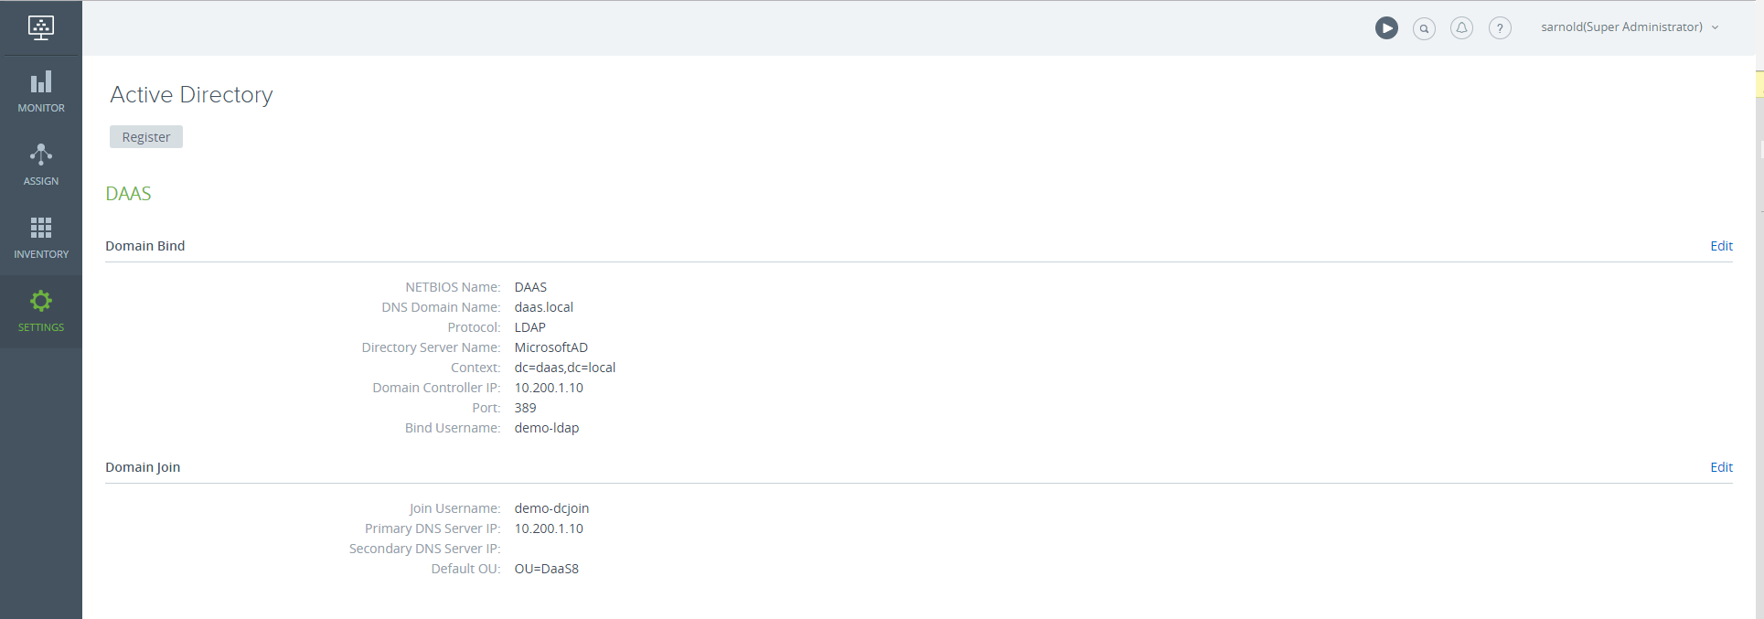

When you click the Register button under the Active Directory option, the Register Active Directory screen (shown below) will pop up.
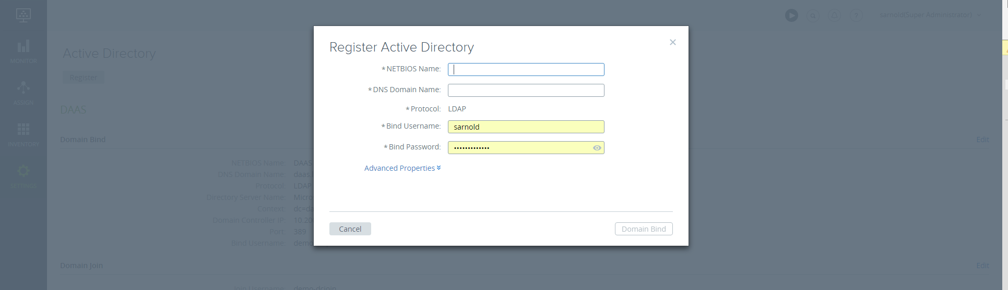

Gather the information below to register an existing domain. Make sure you have created the needed accounts & groups before registering the domain.
Field | Example | Notes
Name | DAAS | NETBIOS name of the domain to be registered
Domain Suffix | daas.local.com
Protocol | LDAP | LDAP or LDAPS
Port | 389 | Typically 389 or 636. This must be opened in your firewall.
Domain Controller IPs | 10.1.1.1 | This is optional
Context | dc=daas,dc=local,dc=com
Domain Bind Account | CN=daasldap,CN=Users | Used for LDAP bind/query. This account can be read only.
Domain Bind Account Password | ********
Joining Account Name | user1 | This account needs to have privileges to do unlimited domain joins.
Joining Account Password | ********
Super Admin Groups | CN=DaaSAdmins, OU=groups | This group has access to the admin portal. Must be at least one user setup here to access the admin portal.
User Groups | CN=DaaSUsers,OU=groups | This group has access to the desktop portal.

Domain Registration
- Refer to your Evolve IP Account Access QRG for your specific log-in credentials. Ask your project manager if you need this information.
- Open browser, load the provided URL for the DaaS Admin Portal / Enterprise Center and enter your log-in credentials. A dialog box with the Terms of Service will pop up, click I agree and Submit to accept. *It will only come up the first time and only if your system admin configured a Terms of Service URL.
- The Domain Bind section is the first field under the Active Directory view. Enter the needed information. Click Domain Bind. If you need to access this information in the future, go to Settings -> Active Directory.
- The Domain Join section is directly underneath Domain Bind. Enter required information and Click Save. A message will display confirming that your domain registration was successful. After saving, all future access will be handled via the DaaS admin portal login screen.

Configuration
The Settings tile provides access to General Settings. Active Directory, Roles & Permissions, Locations, Getting Started, Utility VMs and 2 Factor Authentication.

Networks, the DaaS domain configuration, Session Timeout, User Portal Configurations, quota information, admin roles and multi-factor authentication. The general tab contains settings to control timeouts, all the defaults can be accepted on this page. Additional definitions of the various configuration areas can be found to the right, the domains page is the most frequently used function as it controls the groups that are seen by the DaaS system.
General Settings
Network
This section provides a list of your networks that are being used.
Default Domain
This section is where you register your domain(s) and edit domain information.
Session Timeout
Lists the timeout settings for the Client and the User Portal.

User Portal Configuration
This section is where you list your Help Desk email address, Trouble Ticket System URL, and the External Style Sheet URL.

HTML Access
If you use Blast, this section controls if you delete credentials of the broker session after a HTML connection is closed.

Contact Info
This section is where you list the Admin and Technical contacts for your organization.

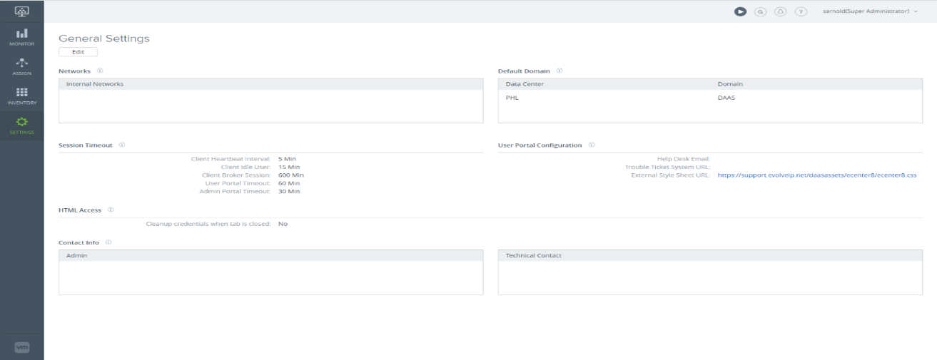
Deploying Desktops
Two desktop images are included with every account, one image will be preloaded for you in the Images section of your Inventory. If additional images are needed contact Evolve IP support for assistance.
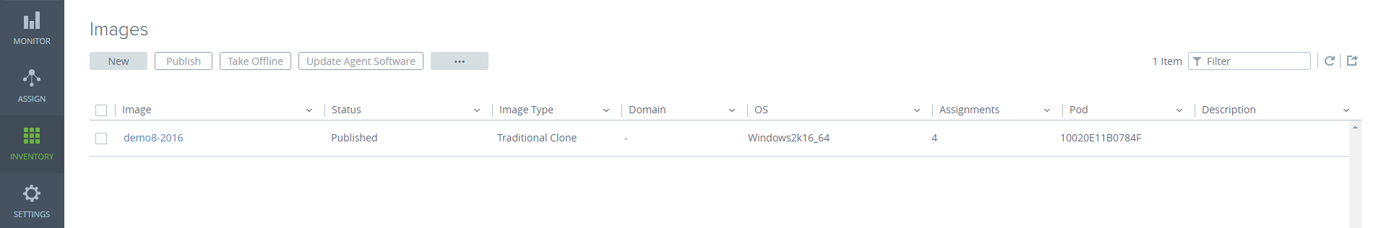
Begin by selecting the ‘Assign’ tile. Next click ‘New’ under Assignments.
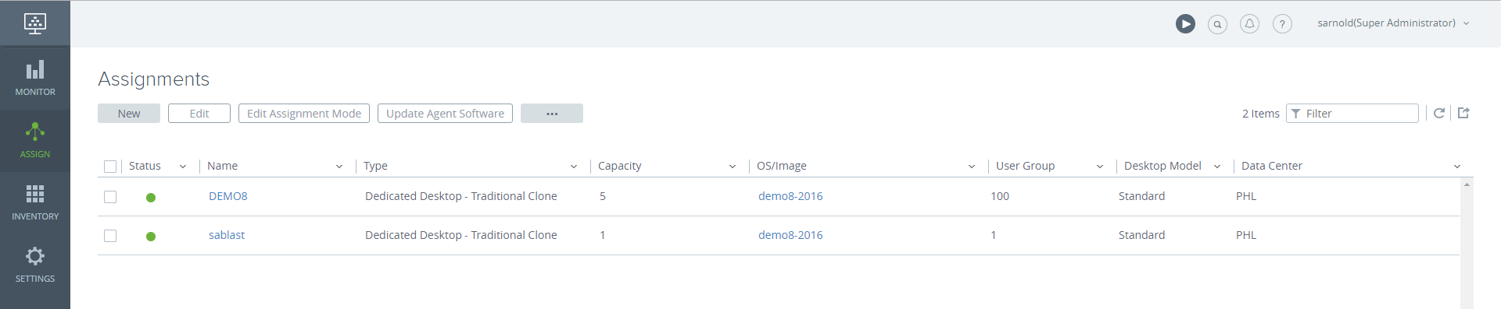
The New Assignment screen will appear. This allows you to deploy desktops or applications, choose the desktop option.
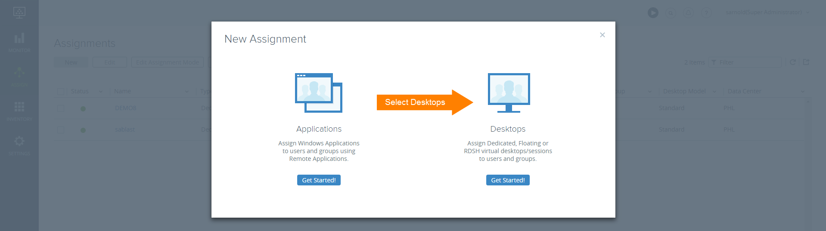
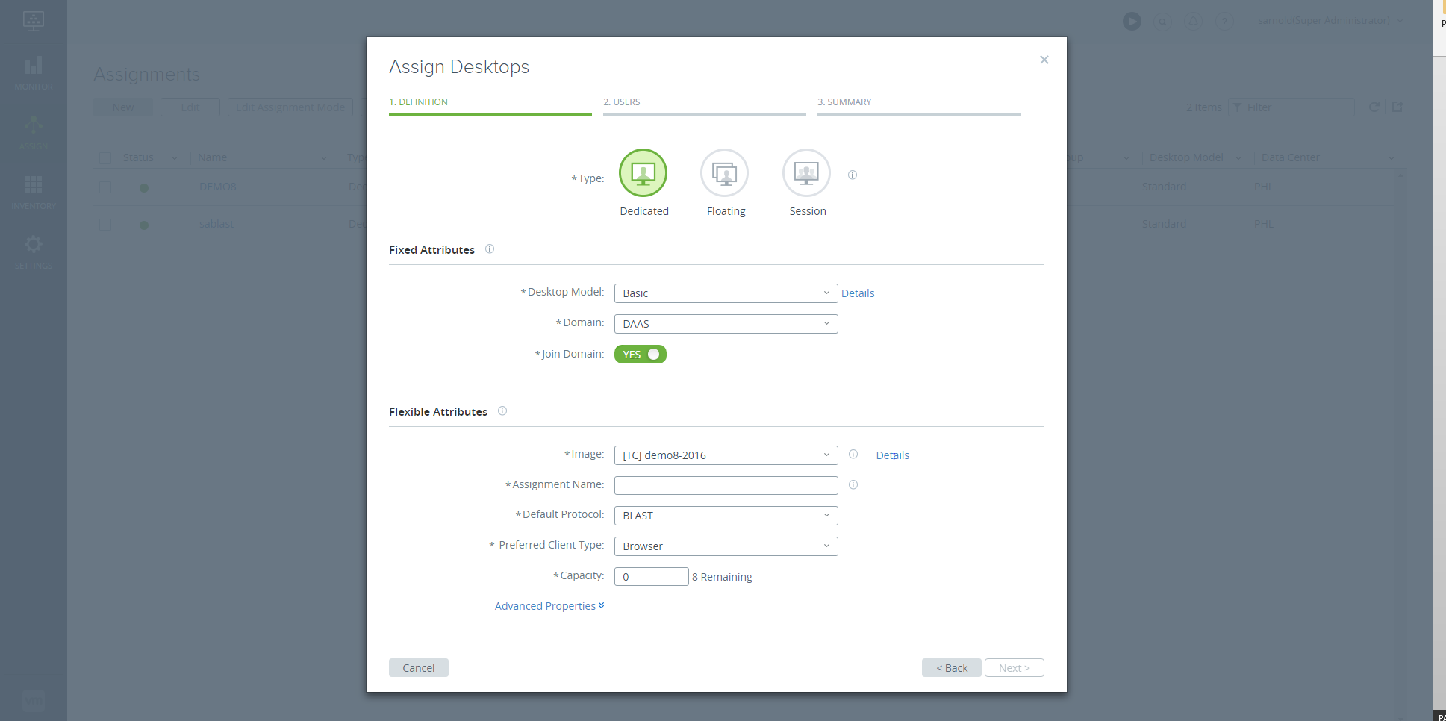
You will be taken to the Assign Desktops screen. There you will define both fixed and flexible attrubutes for your desktop. Fixed attributes include the type (standard, premium, ultimate) and domain. Flexible attributes include the image type, name, connection protocol, client type and capacity.
Begin by selecting the desktop type. Unless otherwise instructed, select Dedicated.

Input the details for your organization’s domain and leave the green join domain toggle set to Yes.
Under flexible attributes, the Assignment Name is the group or pool that you want this desktop to join. You can create a new assignment or add the desktop to an existing assignment.

For PCoIP desktops, change the default protocol to ‘PCOIP’ and change the Preferred Client Type to ‘Horizon Client’. Once you populate the capacity, click ‘Next’ and you will be taken to the Users step.
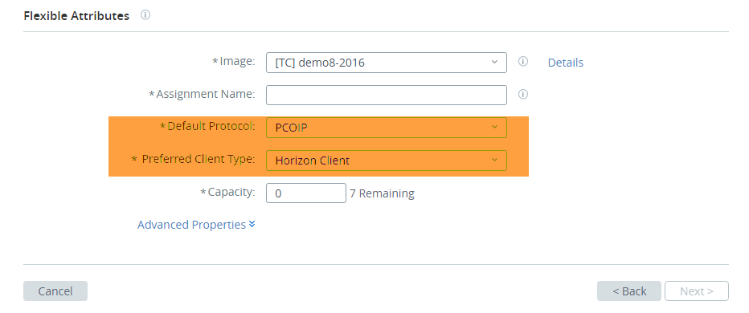

Adding a User to the Desktop
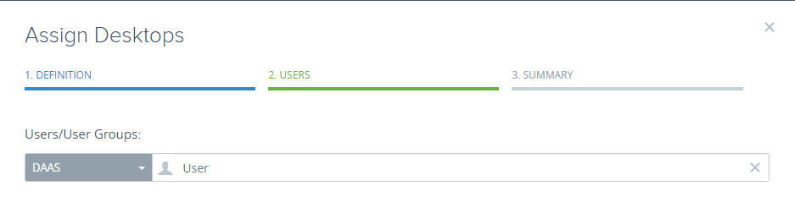
In Active Directory search and populate the name of the user that you want to assign to the desktop.

If you cannot locate the user try the Search Active Directory which will list your organizations entire AD list.
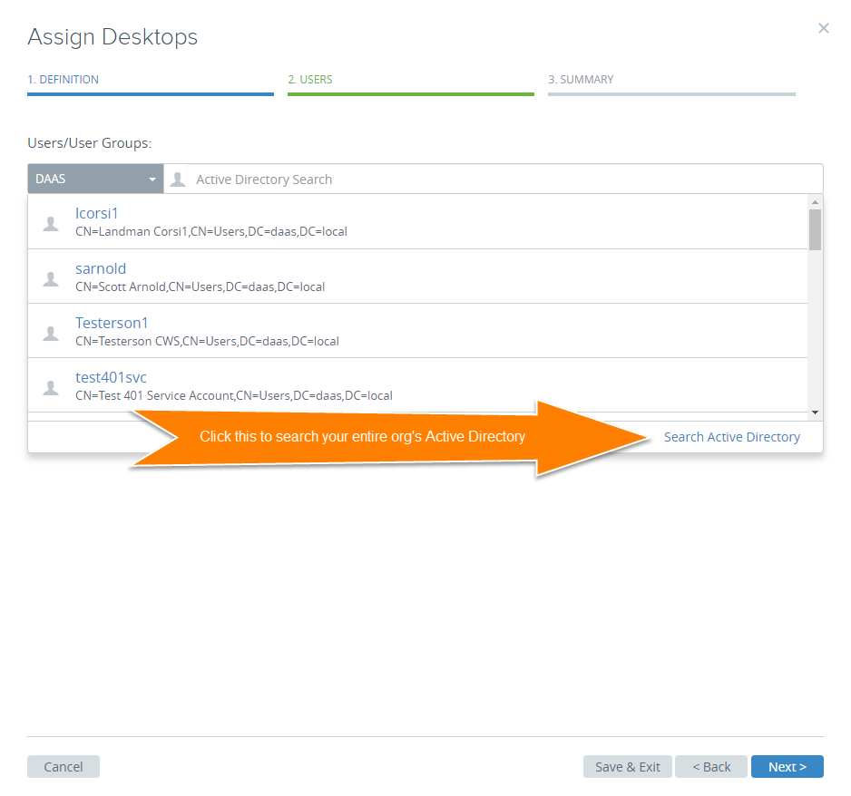

Select the user that you want to assign by clicking on their name. Click ‘Next’ and you will be taken to the Summary Screen.
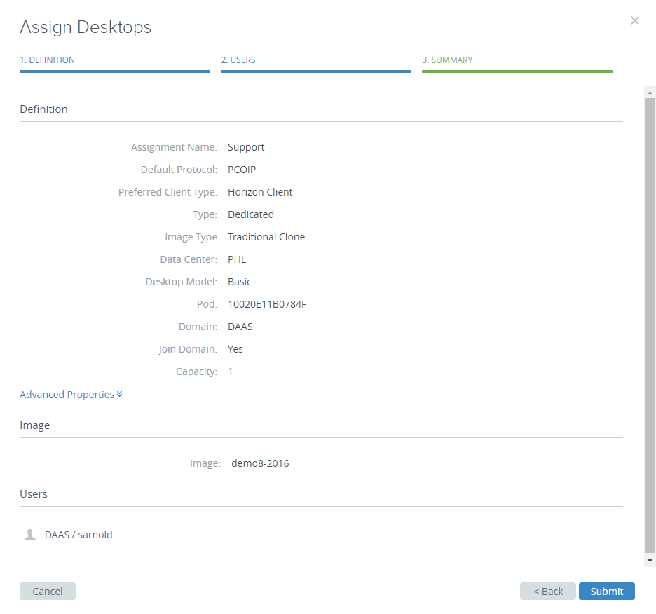
Click ‘Submit’ and your desktop will begin to build within the assignment.

Editing Desktop Assignments
An assignment is a group of desktops based on the same image pattern with same specs and configurations. Also, each DaaS assignment is mapped back to an Active Directory group so administrators can easily manage users and security policies.

Editing a Desktop Assignment to add more desktops
- On the Assignments page, select the assignment to edit and click ‘Edit’.
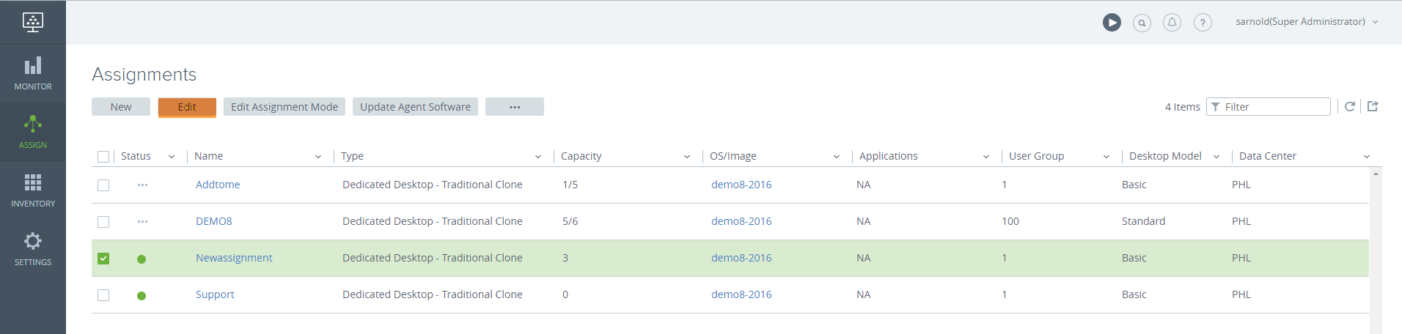
- To change the size, enter desired number of desktops.
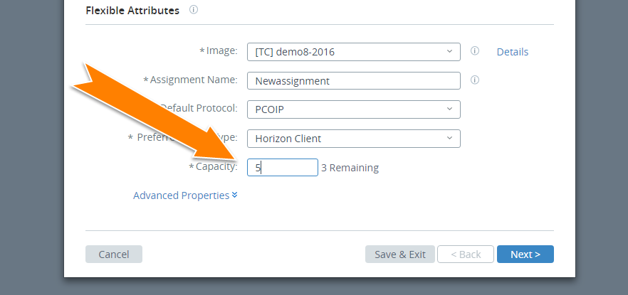
- Click ‘Save and Exit’.
- Your assignment will expand. 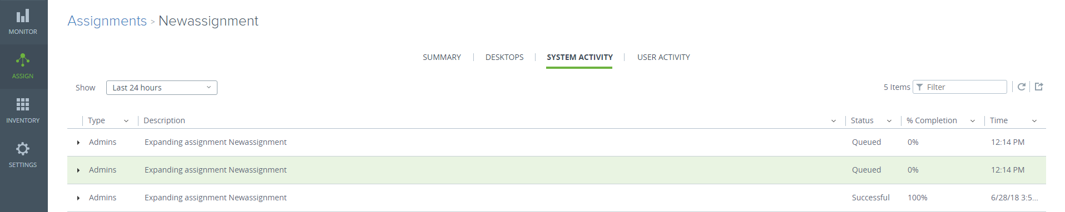
- Assign a user to the new desktop following the same procedure described earlier in the guide.

Creating a New Assignment (Pool) of Desktops
- Click on the Assign tile. Directly under Assignments click the ‘New’ button.
- You will be taken to the Assign Desktops screen. Select the desktop type (dedicated), model, and select your domain. Select the image for the desktop that you want to deploy. The Assignment Name field is where you will give your pool a name. It is a good idea to have the name reflect the type of users in the assignment, for instance: Light User, Heavy User, Corporate, Sales, and Accounting.

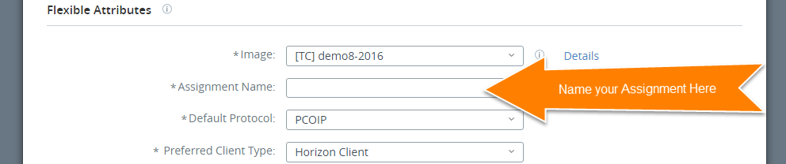

- Set the capacity of your assignment, change the default protocol to ‘PCOIP’ and change the Preferred Client Type to ‘Horizon Client’. Once you populate the capacity, click ‘Next’ and you will be taken to the add users step. Follow the same process to add users described earlier in the guide and this will complete the process of configuring your assignment. Click “Submit” and your assignment will be deployed and visible within the Assign tile.

Deleting Desktops, Assignments and Images

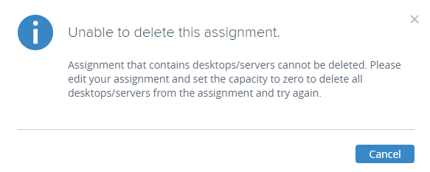
- Select the Assignment that you want to delete. Note that the assignment must not contain any desktops or it will not be able to be deleted until the desktops are deleted from the assignment. You need to unassigned or remove the user from the desktop before you can delete the desktop.

- Select the checkbox by the desktop name. Once you check the box click on the grey button containing three dots and select Unassign. This will remove the user from the desktop. Once there is no user associated with the desktop, you can delete the desktop. When there are no desktops in the assignment, you can delete the assignment.

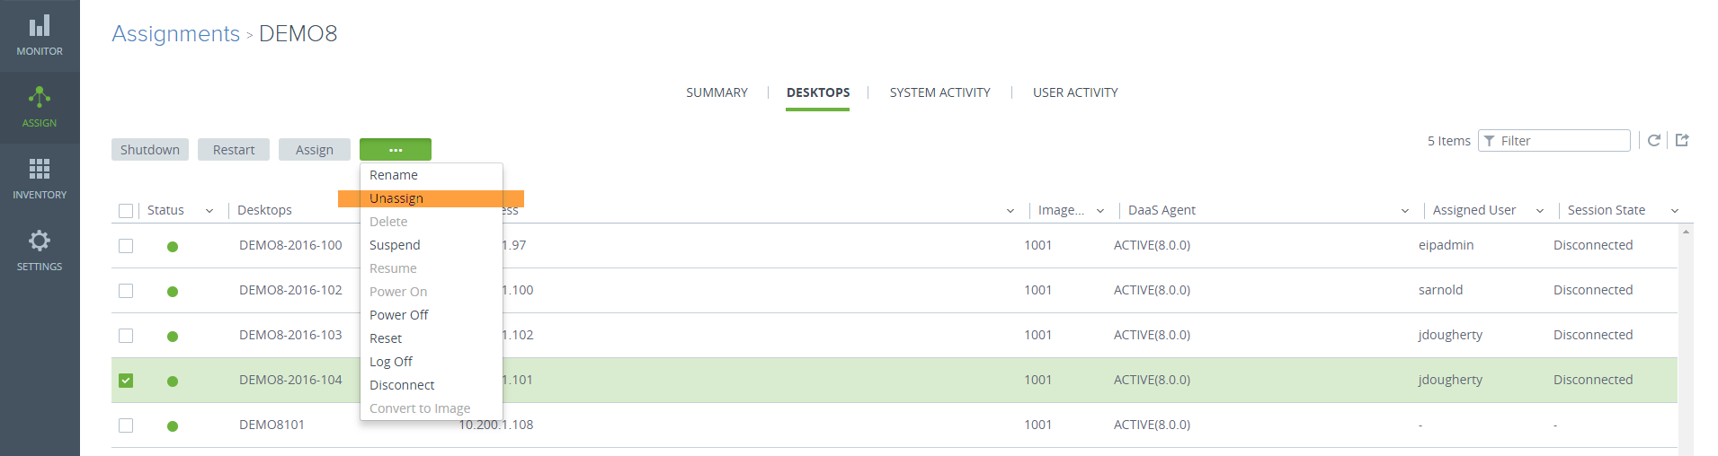

- Select the checkbox by the assignment name. Once you check the box click on the grey button containing three dots and select Unassign. 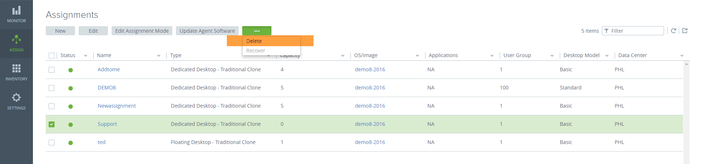
- This will delete the assignment. Click ‘Delete’
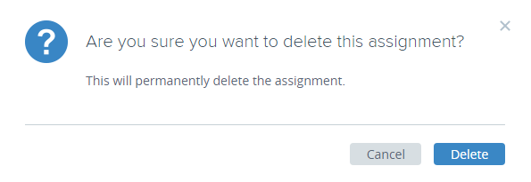

Monitoring
Use the Monitor icon to access desktop information, administrator and user activity, view reports detailing user and desktop mapping, and view notifications.
There are four selections available from the Monitor tile.
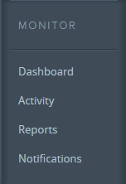
- Dashboard Page shows statistical information about connections and desktop capacity allocation.
- Activity Page shows data regarding current and past events in the system.
- Reports Page shows mapping data for users and desktops in the system.
- Notifications Page shows information regarding system notifications.

View system and user activity for desktop and application assignments.

- Click the Assign icon.
- Click the name of an assignment of the list. The assignments detail page displays.
- Click System Activity or User Activity at the top of the page.

The activity tab displays, showing a list of recent activity for the assignment. You can select from the Shown drop-down menu to adjust the time frame for the list, or filter, refresh, and export the list using the controls on the top right of the page.

