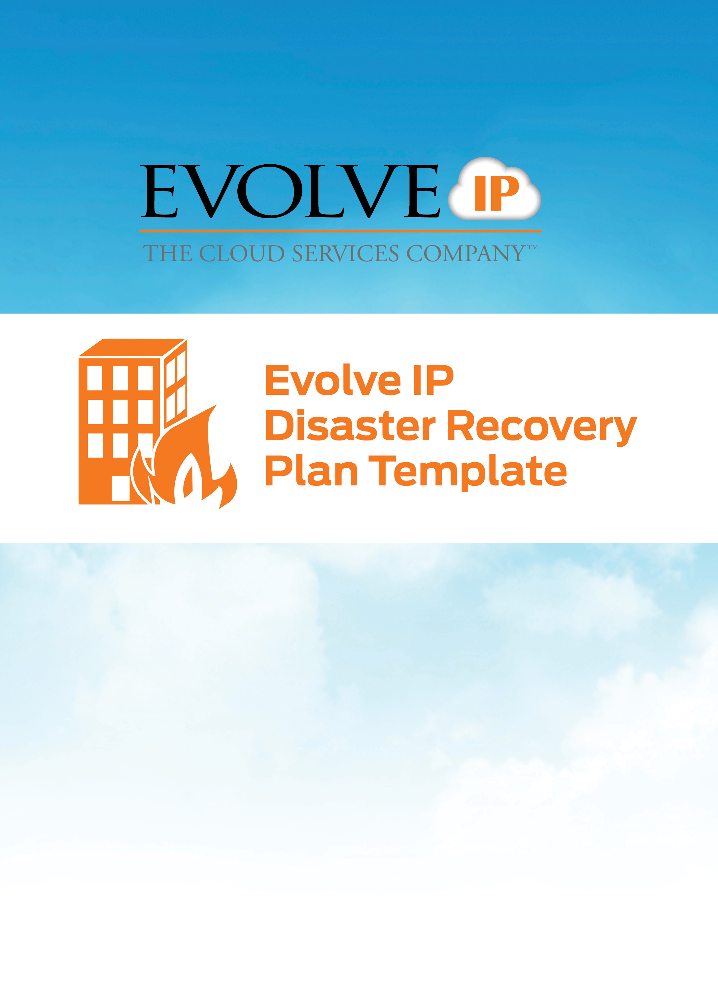

HOW TO USE THIS TEMPLATE

A Disaster Recovery Plan (DR Plan) is a detailed document that contains an abundance of information about the IT operations of your organization. The DR Plan must present that information in a format that is easily consumable during an actual emergency. Evolve IP designed this template to help you capture and organize the critical information that will ensure that your organization’s IT operations are in a position to survive if a disaster transpires.
This template is meant as a guide only. You should review it carefully to determine whether it appropriately fits your needs and you should customize it to best meet your own requirements and goals.
KEY
Orange text = This template includes instructional text, which is represented in blue text. Please review all instructional text to ensure complete understanding of the purpose of each document section and follow those instructions to complete the section in question.
Italicized text = This template also contains examples, which are represented by italicized text. These examples are provided as guidance on to how to complete a section and supplement the information provided in the instructional text. In some cases example text (e.g. bullet lists) may be used as-is, added to, or deleted from while in other cases (e.g. sample table entries) it should be replaced with accurate, organization specific information.
Evolve IP has provided recommendations regarding which sections presumably need to be preserved and which may be deleted with the following color-coded text:
Required = it is probable that all organizations will need to retain and complete this section.
Optional = it is likely that only some organizations will need to include this section.
This template includes time-saving placeholders for you to use with the Find and Replace function to insert the suitable information. These fields are delineated with brackets, like this: {this}. Simply enter each specific term with brackets in the Find field and the appropriate term in the Replace field.
INSTRUCTIONS

Complete all required sections and delete all unnecessary sections, replacing example text and Find and Replace text during the process. Once you have completed all sections, delete all instructional text (including this instruction page) as well as all Required/Optional markers and Find and Replace markers. Update the Table of Contents (right click and select “Update Fields”) and then publish.
Once this document has been completed, you need to provide copies to all stakeholders and all associates who have DR responsibilities. You should create additional hard- and soft-copies for each data center or availability zones that houses your IT systems, including any standby or recovery facilities you have. You will need to ensure that the access to these hard and soft copies is protected to guarantee the integrity of the document.
Additionally, you should schedule time to review the document on a regular basis to ensure continued applicability, and revise it as required.

{Organization Name} Disaster Recovery Plan
14May2015
Version 1

TABLE OF CONTENTS

INTRODUCTION 1
DEFINITION: DISASTER 1
THE PURPOSE OF THE DR PLAN 1
EMERGENCY CONTACT FORM 2
EXTERNAL CONTACTS 3
NOTIFICATION NETWORK 6
SCOPE 7
VERSION INFORMATION & CHANGES 7
DISASTER RECOVERY TEAMS & RESPONSIBILITIES 8
DISASTER RECOVERY LEAD 9
ROLE AND RESPONSIBILITIES 9
CONTACT INFORMATION 9
DISASTER MANAGEMENT TEAM 10
ROLE & RESPONSIBILITIES 10
CONTACT INFORMATION 10
NETWORK TEAM 11
ROLE & RESPONSIBILITIES 11
CONTACT INFORMATION 11
SERVER TEAM 12
ROLE & RESPONSIBILITIES 12
CONTACT INFORMATION 12
APPLICATIONS TEAM 13
ROLE & RESPONSIBILITIES 13
CONTACT INFORMATION 13
DATA AND BACKUPS 14
DATA IN ORDER OF CRITICALITY 14
RESTORING IT FUNCTIONALITY 15
CURRENT SYSTEM ARCHITECTURE 15
IT SYSTEMS 16
CONNECTIVITY 16
NETWORK EQUIPMENT 17
SWITCHES 17
ROUTERS 17
LOAD BALANCERS 17
VPN DEVICES 18
FIREWALLS 18
MISCELLANEOUS NETWORK APPLIANCES 18
SERVERS 19
SEVERITY ONE SYSTEM 20
PROCEDURE 21
SEVERITY TWO SYSTEM 22
PLAN TESTING & MAINTENANCE 23
MAINTENANCE 23
TESTING 23
BUSINESS PROCESS/FUNCTION RECOVERY COMPLETION FORM 24
EVOLVE IP DRAAS SUITE 25

INTRODUCTION

Required
This Disaster Recovery Plan (DR Plan) is the single source for all of the information that describes {Organization’s Name}’s ability to survive a disaster including the processes that must be followed to accomplish disaster recovery.
Edit this section to suit your organization’s needs, making all lists and other copy relevant to your organization.

DEFINITION: DISASTER
Optional
A disaster can be caused by many events resulting in {Organization Name}’s IT department not being able to perform some or all of their regular roles and responsibilities for a period of time. {Organization Name} defines disasters as the following:
- Edit this list to reflect your organization
- One or more vital systems are non-functional
- The building is not available for an extended period of time but all systems are functional within it
- The building is available but all systems are non-functional
- The building and all systems are non-functional
The following events can result in a disaster, requiring this DR document to be activated:
- Edit this list to reflect your organization
- Environmental disaster (flooding, hurricane, fire, etc.)
- Hardware failure / server room issue
- Power outage
- Theft
- Deliberate attack
- Terrorist attack
- Human error

THE PURPOSE OF THE DR PLAN
Required
The purpose for this DR Plan document is to inventory all of the IT infrastructure and capture all of the information relevant to the organization’s ability to recover its IT from a disaster, and document the steps that the organization will follow in the event that a disaster occurs.
The top priority of {Organization Name} will be to enact the steps outlined in this DR Plan to bring all of the organization’s groups and departments back to business-as-usual as quickly as possible. This includes:
- Edit this list to reflect your organization
- Preventing the loss of the organization’s resources such as hardware, data and physical IT assets
- Minimizing downtime related to IT
- Keeping the business running in the event of a disaster
This DR Plan will also detail how this document is to be maintained and tested.

EMERGENCY CONTACT FORM

First Name | Last Name | Title | Contact Type | Contact information
 |  |  | Work
 |  |  | Mobile
 |  |  | Alternate
 |  |  | Email
 |  |  | Work
 |  |  | Mobile
 |  |  | Alternate
 |  |  | Email
 |  |  | Work
 |  |  | Mobile
 |  |  | Alternate
 |  |  | Email
 |  |  | Work
 |  |  | Mobile
 |  |  | Alternate
 |  |  | Email
 |  |  | Work
 |  |  | Mobile
 |  |  | Alternate
 |  |  | Email

EXTERNAL CONTACTS
First Name | Last Name | Title | Contact Type | Contact information
Property Manager / Landlord
Account #:
 |  |  | Work
 |  |  | Mobile
 |  |  | Email
Power Company
Account #:
 |  |  | Work
 |  |  | Mobile
 |  |  | Email
Security Company
Account #:
 |  |  | Work
 |  |  | Mobile
 |  |  | Email
Network Provider
Account #:
 |  |  | Work
 |  |  | Mobile
 |  |  | Email
Telecom Carrier
Account #:
 |  |  | Work
 |  |  | Mobile
 |  |  | Email
Managed Services / Help Desk
Account #:
 |  |  | Work
 |  |  | Mobile
 |  |  | Email
Server Supplier
Account #:
 |  |  | Work
 |  |  | Mobile
 |  |  | Email
Workstation Supplier
Account #:
 |  |  | Work
 |  |  | Mobile
 |  |  | Email
Insurance
Account #:
 |  |  | Work
 |  |  | Mobile
 |  |  | Email
Off-site Storage
Account #:
 |  |  | Work
 |  |  | Mobile
 |  |  | Email
Power Generator
Account #:
 |  |  | Work
 |  |  | Mobile
 |  |  | Email
Other
Account #:
 |  |  | Work
 |  |  | Mobile
 |  |  | Email

NOTIFICATION NETWORK

SCOPE
Required
The {Organization Name} DR Plan takes all of the following technology areas into consideration:
- Edit this list to reflect your organization
- Network Infrastructure
- Servers Infrastructure
- Telephony System
- Data Storage and Backup Systems
- Data Output Devices
- End-user Computers
- Organizational Software Systems
- Database Systems
- IT Documentation
This DR Plan does not take into consideration any non-IT, personnel, Human Resources and real estate related disasters.

VERSION INFORMATION & CHANGES
Required
Any changes, edits and updates made to the DR Plan will be recorded in here. It is the responsibility of the Disaster Recovery Lead to ensure that all existing copies of the DR Plan are up to date. Whenever there is an update to the DR Plan, {Organization Name} requires that the version number be updated to indicate this.
Add rows as required as the DR Plan is amended.
Name of Person Making Change | Role of Person Making Change | Date of Change | Version Number | Notes
Bob Jones | DR Lead | 01/01/14 | 1.0 | Initial version of DR Plan
Bob Jones | DR Lead | 01/01/15 | 2.0 | Revised to include new Evolve IP availability zones
Lisa Smith | CEO | 04/03/15 | 2.1 | Replaced Bob Jones as DR Lead

DISASTER RECOVERY TEAMS & RESPONSIBILITIES
Required
In the event of a disaster, different teams will be required to assist the IT department in their effort to restore normal functionality to the employees of {Organization Name}. The different teams and their responsibilities are as follows:
- Edit this list to reflect your organization
- Disaster Recovery Lead(s)
- Disaster Management Team
- Network Team
- Server Team
- Applications Team
The lists of roles and responsibilities in this section have been created by {Organization Name} and reflect the likely tasks that team members will have to perform. Disaster Recovery Team members will be responsible for performing all of the tasks below. In some disaster situations, Disaster Recovery Team members will be called upon to perform tasks not described in this section.
The following teams will vary depending on the size of your organization. Some teams/roles may be combined or may be split into more than one team.

DISASTER RECOVERY LEAD
Required
The Disaster Recovery Lead is responsible for making all decisions related to the Disaster Recovery efforts. This person’s primary role will be to guide the disaster recovery process and all other individuals involved in the disaster recovery process will report to this person in the event that a disaster occurs at {Organization Name}, regardless of their department and existing managers. All efforts will be made to ensure that this person be separate from the rest of the disaster management teams to keep his/her decisions unbiased. As a result, the Disaster Recovery Lead will not be a member of other Disaster Recovery groups in {Organization Name}.

ROLE AND RESPONSIBILITIES
- Edit this list to reflect your organization
- Make the determination that the organization is declaring that a disaster has occurred and trigger the DR Plan and related processes.
- Initiate the DR Notification Network.
- Be the single point of contact for and oversee all of the DR Teams.
- Organize and chair regular meetings of the DR Team leads throughout the disaster.
- Present to the Management Team on the state of the disaster and the decisions that need to be made.
- Organize, supervise and manage all DR Plan test and author all DR Plan updates.

CONTACT INFORMATION
Add or delete rows to reflect the size the Disaster Recovery Team in your organization.
Name | Role/Title | Work Phone Number | Home Phone Number | Mobile Phone Number
Lisa Smith | Primary Disaster Lead | 555-555-5555 | 555-555-5555 | 555-555-5555
Bob Jones | Secondary Disaster Lead | 555-555-5555 | 555-555-5555 | 555-555-5555
Evolve IP | Managed IT | 877.459.4347 x5

DISASTER MANAGEMENT TEAM
OPTIONAL
The Disaster Management Team that will oversee the entire disaster recovery process and will be the first team required to take action in the event of a disaster. This team will evaluate the disaster and determine the steps required to get the organization back to business as usual.
In a small organization, these roles may be performed by the Disaster Recovery Lead.

ROLE & RESPONSIBILITIES
- Edit this list to reflect your organization
- Set the DR Plan into motion after the Disaster Recovery Lead has declared a disaster
- Determine the magnitude and class of the disaster
- Determine what systems and processes have been affected by the disaster
- Communicate the disaster to the other disaster recovery teams
- Determine what first steps need to be taken by the disaster recovery teams
- Keep the disaster recovery teams on track with pre-determined expectations and goals
- Keep a record of money spent during the disaster recovery process
- Ensure that all decisions made abide by the DR Plan and policies set by {Organization Name}
- Get the secondary site ready to restore business operations
- Ensure that the secondary site is fully functional and secure
- Create a detailed report of all the steps undertaken in the disaster recovery process
- Notify the relevant parties once the disaster is over and normal business functionality has been restored
- After {Organization Name} is back to business as usual, this team will be required to summarize any and all costs and will provide a report to the Disaster Recovery Lead summarizing their activities during the disaster

CONTACT INFORMATION
Add or delete rows to reflect the size the Disaster Management Team in your organization.
Name | Role/Title | Work Phone Number | Home Phone Number | Mobile Phone Number
Lisa Smith | “Regular” title | 555-555-5555 | 555-555-5555 | 555-555-5555
Bob Jones | “Regular” title | 555-555-5555 | 555-555-5555 | 555-555-5555
Evolve IP | Managed IT | 877.459.4347 x5

NETWORK TEAM
Required
The Network Team will be responsible for assessing damage specific to any network infrastructure and for provisioning data and voice network connectivity including WAN, LAN, and any telephony connections internally within the organization as well as telephony and data connections with the outside world. They will be primarily responsible for providing baseline network functionality and may assist other IT DR Teams as required.

ROLE & RESPONSIBILITIES
- Edit this list to reflect your organization
- In the event of a disaster that does not require migration to / from Evolve IP availability zones, the team will determine which network services are not functioning at the primary availability zones
- If multiple network services are impacted, the team will prioritize the recovery of services in the manner and order that has the least business impact.
- If network services are provided by third parties, the team will communicate and co-ordinate with these third parties to ensure recovery of connectivity.
- In the event of a disaster that does require migration to Evolve IP availability zones the team will ensure that all network services are brought online at the secondary availability zones
- Once critical systems have been provided with connectivity, employees will be provided with connectivity in the following order:
  - All members of the DR Teams
  - All C-level and Executive Staff
  - All IT employees
  - All remaining employees
- Install and implement any tools, hardware, software and systems required in the standby availability zone
- Install and implement any tools, hardware, software and systems required in the primary availability zone
- After {Organization Name} is back to business as usual, this team will be summarize any and all costs and will provide a report to the Disaster Recovery Lead summarizing their activities during the disaster

CONTACT INFORMATION
Add or delete rows to reflect the size of the Network Team in your organization.
Name | Role/Title | Work Phone Number | Home Phone Number | Mobile Phone Number
Lisa Smith | Network Manager | 555-555-5555 | 555-555-5555 | 555-555-5555
Bob Jones | Network Administrator | 555-555-5555 | 555-555-5555 | 555-555-5555
Evolve IP | Managed IT | 877.459.4347 x5

SERVER TEAM
Required
The Server Team will be responsible for providing the physical server infrastructure required for the organization to run its IT operations and applications in the event of and during a disaster. They will be primarily responsible for providing baseline server functionality and may assist other IT DR Teams as required.

ROLE & RESPONSIBILITIES
- Edit this list to reflect your organization
- In the event of a disaster that does not require migration to / from Evolve IP availability zones, the team will determine which servers are not functioning at the primary availability zone
- If multiple servers are impacted, the team will prioritize the recovery of servers in the manner and order that has the least business impact. Recovery will include the following tasks:
  - Assess the damage to any servers
  - Restart and refresh servers if necessary
- Ensure that secondary servers located in Evolve IP availability zones are kept up-to-date with system patches
- Ensure that secondary servers located in Evolve IP availability zones are kept up-to-date with application patches
- Ensure that secondary servers located in Evolve IP availability zones are kept up-to-date with data copies
- Ensure that the secondary servers located in the standby availability zones are backed up appropriately
- Ensure that all of the servers in the standby availability zones abide by {Organization Name}’s server policy
- Install and implement any tools, hardware, and systems required in the standby availability zones
- Install and implement any tools, hardware, and systems required in the primary availability zones
- After {Organization Name} is back to business as usual, this team will be summarize any and all costs and will provide a report to the Disaster Recovery Lead summarizing their activities during the disaster

CONTACT INFORMATION
Add or delete rows to reflect the size of the Server Team in your organization.
Name | Role/Title | Work Phone Number | Home Phone Number | Mobile Phone Number
Mandy Bell | Operations Manager | 555-555-5555 | 555-555-5555 | 555-555-5555
Matthew Davis | Systems Administrator | 555-555-5555 | 555-555-5555 | 555-555-5555
Evolve IP | Managed IT | 877.459.4347 x5

APPLICATIONS TEAM
Required
The Applications Team will be responsible for ensuring that all organization applications operate as required to meet business objectives in the event of and during a disaster. They will be primarily responsible for ensuring and validating appropriate application performance and may assist other IT DR Teams as required.

ROLE & RESPONSIBILITIES
- Edit this list to reflect your organization
- In the event of a disaster that does not require migration to / from Evolve IP availability zones, the team will determine which applications are not functioning at the primary availability zones
- If multiple applications are impacted, the team will prioritize the recovery of applications in the manner and order that has the least business impact. Recovery will include the following tasks:
  - Assess the impact to application processes
  - Restart applications as required
  - Patch, recode or rewrite applications as required
- Ensure that secondary servers located in Evolve IP availability zones are kept up-to-date with application patches
- Ensure that secondary servers located in Evolve IP availability zones are kept up-to-date with data copies
- Install and implement any tools, software and patches required in the standby availability zones
- Install and implement any tools, software and patches required in the primary availability zones
- After {Organization Name} is back to business as usual, this team will be summarize any and all costs and will provide a report to the Disaster Recovery Lead summarizing their activities during the disaster

CONTACT INFORMATION
Add or delete rows to reflect the size of the Application Team in your organization.
Name | Role/Title | Work Phone Number | Home Phone Number | Mobile Phone Number
Jack Rand | Program Manager | 555-555-5555 | 555-555-5555 | 555-555-5555
Gary White | Systems Administrator | 555-555-5555 | 555-555-5555 | 555-555-5555
Evolve IP | Managed IT | 877.459.4347 x5

DATA AND BACKUPS
Required
This section explains where all of the organization’s data resides as well as where it is backed up to. Use this information to locate and restore data in the event of a disaster.
In this section it is important to explain where the organization’s data resides. Discuss the location of all the organization’s servers, backups and offsite backups and list what information is stored on each of these.

DATA IN ORDER OF CRITICALITY
Please list all of the data in your organization in order of their criticality. Add or delete rows as needed to the table below.
Rank | Data | Data Type | Back-up Frequency | Backup Location(s) / Evolve IP Backup Product (Cloud Backup / Reflection)
1 | {Data Name or Group} | {Confidential, Public, Personally identifying information} | {Frequency that data is backed up} | {Where data is backed up to}
2
3
4
5
6
7
8
9
10

RESTORING IT FUNCTIONALITY
Required
Should a disaster actually occur and {Organization Name} need to exercise this plan, this section will be referred to frequently as it will contain all of the information that describes the manner in which {Organization Name}’s information system will be recovered.
This section will contain all of the information needed for the organization to get back to its regular functionality after a disaster has occurred. It is important to include all Standard Operating Procedures documents, run-books, network diagrams, software format information etc. in this section.

CURRENT SYSTEM ARCHITECTURE
Required
In this section, include a detailed system architecture diagram. Ensure that all of the organization’s systems and their locations are clearly indicated.
{System Architecture Diagram}
Example:
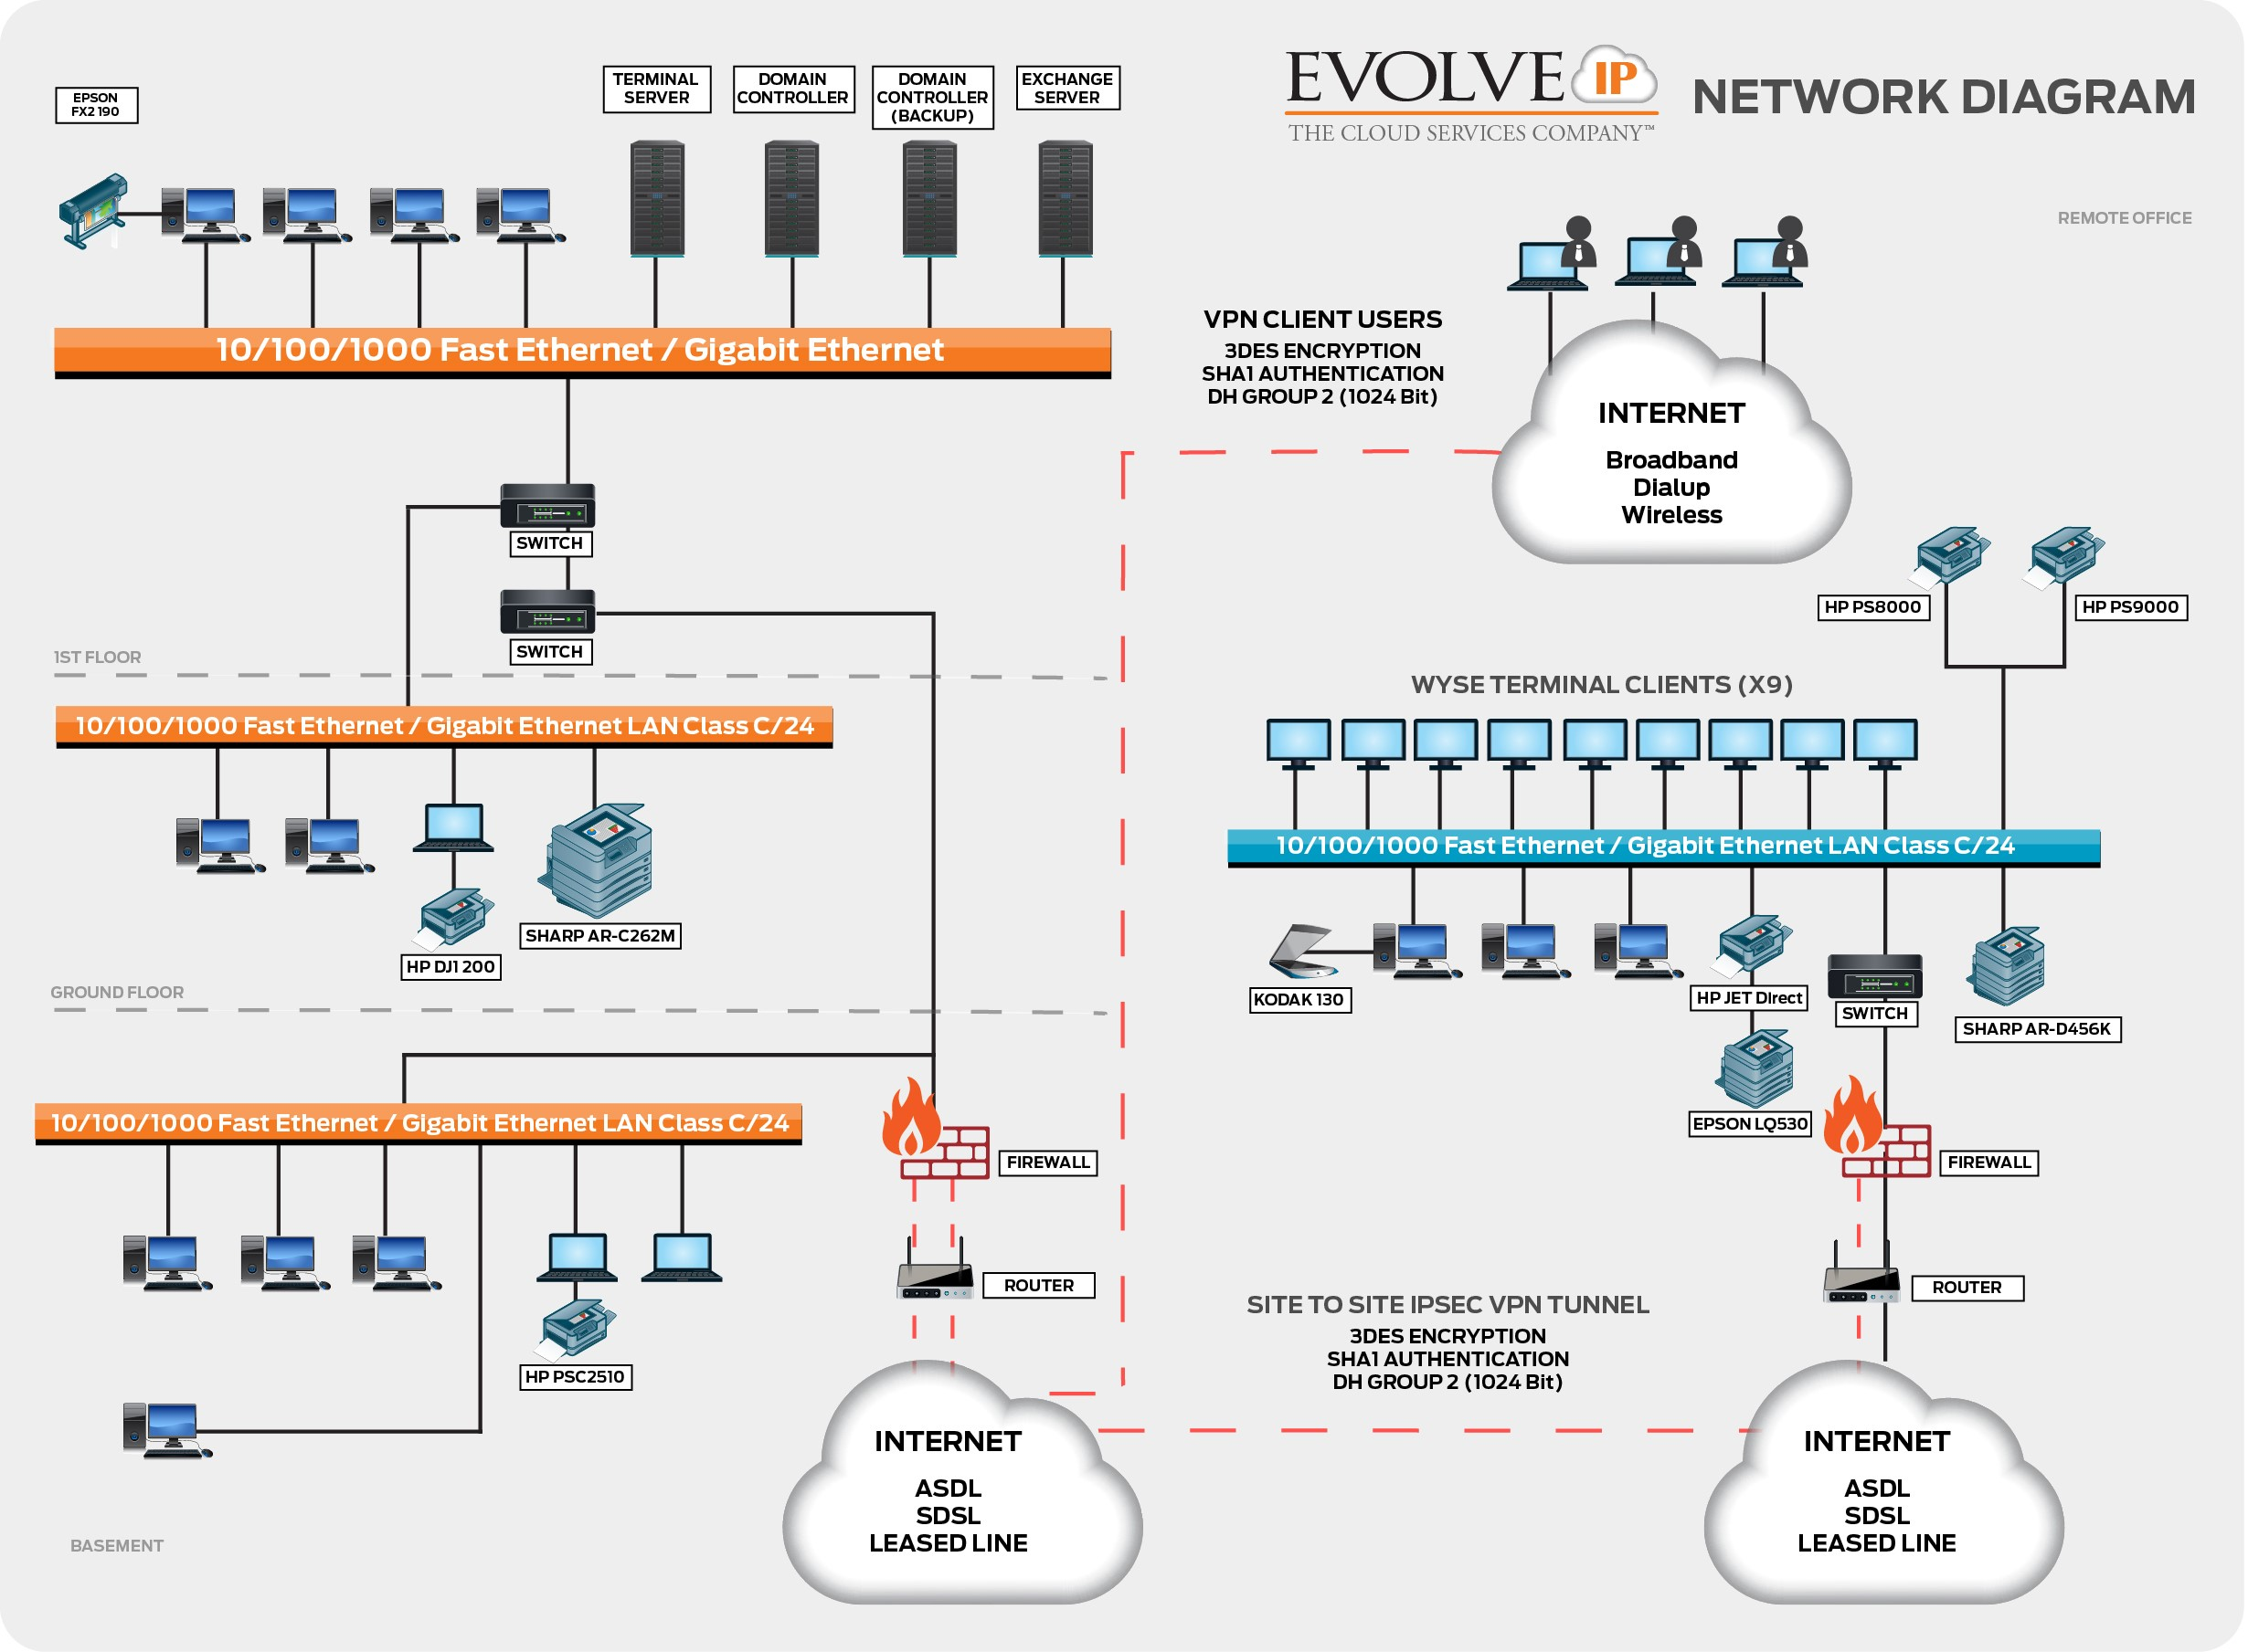

IT SYSTEMS
Please list all of the IT Systems in your organization in order of their criticality. Next, list each system’s components that will need to be brought back online in the event of a disaster. Add or delete rows as needed to the table below.
Rank | IT System | System Components (In order of importance)
1
1
1
2
2
2
3
3
3
4

CONNECTIVITY

Provider | Circuit Type | Bandwidth | CPE | CPE Gear Model | Address, City State ZIP | Onsite Location | Notes
Cogent | Internet | 1 Gbps | No |  | 989 Old Eagle School, Wayne PA 19087 | Network Closet Floor 1 Rack 2 Slot 40 | Primary Internet circuit
Level 3 | MPLS | 50 Mbps | Yes | Cisco 3750 | 989 Old Eagle School, Wayne PA 19087 | Network Closet Floor 1 Rack 2 Slot 38 | Connection to Ohio Office
Cogent | Internet | 10MB | No |  | 989 Old Eagle School, Wayne PA 19087 | Network Closet Floor 1 Rack 2 Slot 37 | Backup Internet connectivity

NETWORK EQUIPMENT

SWITCHES
Make/Model | Description | MGMT IP | Misc. Details

ROUTERS
Make/Model | Description | MGMT IP | Misc. Details

LOAD BALANCERS

Make/Model | Description | MGMT IP | VIP Details

VPN DEVICES
Make/Model | Description | MGMT IP | Tunnel Details

FIREWALLS
Make/Model | Description | MGMT IP | Notes

MISCELLANEOUS NETWORK APPLIANCES

Make/Model | Description | MGMT IP | Notes

SERVERS
Note: (Rank of “1” = most important)

Name | Rank | Type | VM or PHY | CPU | RAM | Disk | OS Version | Purpose

SEVERITY ONE SYSTEM
When determining the right Disaster Recovery services for your organization, there are three aspects to consider:
- Source of System – Whether your system is onsite, in the Evolve IP Cloud, or elsewhere.
- Recovery Point Objective (RPO) – How current your data is at the recovery site.
- Recovery Time Objective (RTO) – How long it should take to bring an environment back online once a disaster or major incident is declared.
Days
Hours
Minutes
Days
Hours
Minutes
Event
Past
Future
RPO
RTO

In this section you will be required to rank each system’s components in order of severity, supplying the information that each system will require to bring it back online.
EXAMPLE:
System Name | {State the name of the System here}
Server Name | {State the name of the specific server here}
Recovery Time Objective | {State the IT Component’s Recovery Time Objective here}
Recovery Point Objective | {State the IT Component’s Recovery Point Objective here}
Replication Target Site | Evolve IP East / West
Replication Technology | DRaaS ZT
Backup Target | Evolve IP Cloud Backup or Reflection
Backup Job Frequency | Nightly
Last Restore Test

PROCEDURE
The following are the steps associated with bringing {Component Name} back online in the event of a disaster or system failure.
Step | Action | Responsibility
1 | {Step 1 Action} | {Person/group responsible}
2

3

4

5

SEVERITY TWO SYSTEM
Repeat as above as needed for as many systems as the organization makes use of.

PLAN TESTING & MAINTENANCE
Required
While efforts will be made initially to construct this DR Plan is as complete and accurate a manner as possible, it is essentially impossible to address all possible problems at any one time. Additionally, over time the Disaster Recovery needs of the organization will change. As a result of these two factors this plan will need to be tested.

MAINTENANCE
Required
The DR Plan will be updated {indicate frequency} or any time a major system update or upgrade is performed, whichever is more often. The Disaster Recovery Lead will be responsible for updating the entire document, and so is permitted to request information and updates from other employees and departments within the organization in order to complete this task.
Maintenance of the plan will include (but is not limited to) the following:
- Edit this list as required
- Ensuring that all team lists are up to date
- Reviewing the plan to ensure that all of the instructions are still relevant to the organization
- Making any major changes and revisions in the plan to reflect organizational shifts, changes and goals
- Ensuring that the plan meets any requirements specified in new laws
During the Maintenance periods, any changes to the Disaster Recovery Teams must be accounted for. If any member of a Disaster Recovery Team no longer works with the company, it is the responsibility of the Disaster Recovery Lead to appoint a new team member.

TESTING
Required
{Organization Name} is committed to ensuring that this DR Plan is functional. The DR Plan should be tested every {indicate frequency} in order to ensure that it is still effective. Testing the plan will be carried out as follows:
Select which method(s) your organization will employ to test the DR Plan
- DR Rehearsal: Team members verbally go through the specific steps as documented in the plan to confirm effectiveness, identify gaps, bottlenecks or other weaknesses. This test provides the opportunity to review a plan with a larger subset of people, allowing the DR Plan Lead to make appropriate changes to the plan. Staff should be familiar with procedures, equipment, and all Evolve IP availability zones (if required).
- Failover Testing: Under this scenario, servers and applications are brought online in an isolated environment. There’s no impact to existing operations or uptime. Systems administrators ensure that all operating systems come up cleanly. Application administrators validate that all applications perform as expected.
- Live-Failover Testing: A live-failover test activates the total DR Plan. The test will disrupt normal operations, and therefore should be approached with caution. Ensure you have completed several iterations of steps 1 and 2 before proceeding with this step. Additionally, communicate all expected disruptions well in advance of performing this test.
Any gaps in the DR Plan that are discovered during the above phases will be addressed by the Disaster Recovery Lead as well as any resources that he/she will require.

BUSINESS PROCESS/FUNCTION RECOVERY COMPLETION FORM
The DR Lead is responsible for completing and signing this form for each process recovered. Please use a separate form for each recovered business process.

NAME OF BUSINESS PROCESS:
Completion Date of Work by DR Team | {ENTER DATE HERE}
Date of Transition Back to Business Unit Management | {ENTER DATE HERE}
I confirm that the work of the Disaster Recovery Team has been completed in accordance with the DR Plan for the above process and that normal business operations have been effectively restored.

DR Team Lead Name: ______________________________________________________________________

Signature: _______________________________________________________________________________

Date: ____________________________________

Comments:

I confirm that above business process is now acceptable for normal working conditions.

DR Team Lead Name: ______________________________________________________________________

Title: ___________________________________________________________________________________

Signature: _______________________________________________________________________________

Date: ____________________________________

EVOLVE IP DRAAS SUITE
The Evolve IP DRaaS Suite has been carefully developed to provide a cost effective, dependable set of products to protect the modern business. Evolve IP’s cloud-based Disaster Recovery services provides customers with data loss prevention and various business continuity options leveraging Evolve IP’s best-of-breed IT infrastructure as a service (IaaS).
Evolve IP’s DRaaS Suite products are designed to deliver a wide range of RPO/RTO service levels, with RPO’s measured in seconds, not hours. The Evolve IP DRaaS Suite includes:
  - DRaaS SRM – Standard and Premium
  - DRaaS ZT – Standard and Premium
  - DRaaS DT – One-to-One and Many-to-One
  - Cloud Backup / Reflection- Standard and Premium
  - DRaaS DK – One-to-one

