

Evolve Contact Suite (ECS)
High Availability and Security Architecture

Evolve IP® Guide
Copyright Notice
Copyright © 2019 Evolve IP, LLC.
All rights reserved.

Any technical documentation that is made available by Evolve IP, LLC is proprietary and confidential and is considered the copyrighted work of Evolve IP, LLC.

This publication is for distribution under Evolve IP non-disclosure agreement only. No part of this publication may be duplicated without the express written permission of Evolve IP, LLC 989 Old Eagle School Road, Wayne, PA 19087.

Evolve IP reserves the right to make changes without prior notice.

Table of Contents
Table of Contents 2
Foreword 3
Evolve Contact Suite Introduction 4
Platform Global Architecture Overview 4
Software Overview 5
Single Geo Site Topology Components 5
Single Geo Site High Availability and Redundancy 7
Overview 7
Node Manager 9
Perimeter Services 10
SIP Proxy Services 10
Single Site Scalability and Operability 11
ECS’s Scalable Platform 11
Platform Administration 12
Operability – Using the HA Monitor 12
ECS Platform - Geo Redundancy and Scalability 12
Goals 12
Components 13
Single Geo Site Scope 13
Evolve IP Network 13
Multi-site configuration 13
Evolve Contact Control (ECC) 13
Evolve Contact Monitor (ECM) 14
Data Sync 14
Site Lookup Service 14
Failover between Geo Sites 14
ECS Platform Security 15
Authentication 15
Access Control 15
Role Based Authorization 16
Client Security 16
Networking 17
Confidentiality and Data Security 17
Auditing 18
Timeline 18

Foreword
This document describes the Evolve Contact Suite (ECS) platform architecture which provides Geo redundancy, high availability, redundancy and scalability. This document also describes the platform’s security architecture and the layered topology that was selected to provide safe, secured and authorized use of the platform by all its users and roles. 3rd-party High Availability (HA) components are out of this document scope.

Evolve Contact Suite Introduction
Evolve Contact Suite’s advanced features provide contact center leaders with powerful real-time control and visibility of their agents along with rich operational insights. From quality management, to customer surveys, to CRM integration, to business intelligence, the solution offers tools that streamline agent interactions and enhance customer experience.
Evolve IP’s multi-channel contact center provides organizations with a sophisticated, cloud-based service that delivers real business value. Leverage Evolve IP’s redundant and compliant cloud architecture for enterprise-grade business continuity while enabling end customers to interact across any communication channel with agents operating from anywhere.

Platform Global Architecture Overview
The Evolve Contact Suite (ECS) platform spans over multiple data centers in globally dispersed geographies. Each data center operates an ECS Geo Site which implements component-based redundancy with no single points of failure. Each ECS customer is in fact a tenant operated on a SaaS platform. ECS multi-site configuration allows for tenants to be served from any Geo location (by default the closest) thus providing scalability, geographic redundancy, and Disaster Recovery for its customer base.
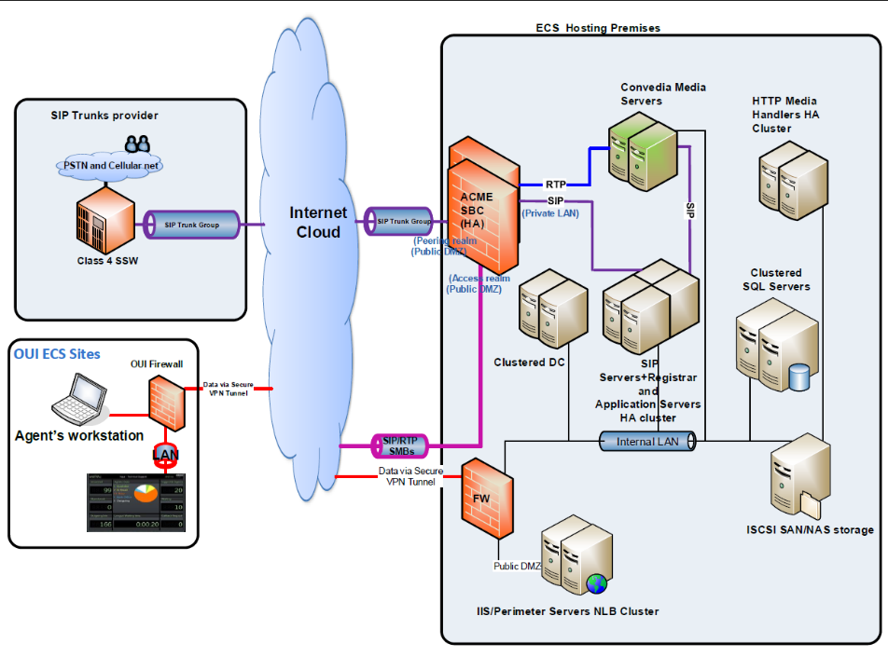

Software Overview
ECS software architecture is built on top of Microsoft .NET framework. It implements various Microsoft foundations (WPF, WF, WCF). Most of the code is written as managed C# while the SIP server is an unmanaged C++ module wrapped by a C# container. The SIP servers (built using an open source ReSIProcate components) handles SIP signaling only while RTP is terminated directly to other SIP UA’s (Media Server and agents’ SIP terminals).
ECS server can be deployed on top of standard Microsoft servers or on standard virtualization platforms such as VMware or Hyper-V.
ECS exposes a Restful API that enables third party systems to implement their own client while handling the interaction state using API only.
In addition, ECS enables third party systems to subscribe to events and be notified on every change in states and KPI’s for entities like agents, interactions and queues.

Single Geo Site Topology Components
ECS’s high availability and security features are based on a clear separation of ECS’s client and server modules. Client applications are housed on the agent or supervisor’s local machine with connection to the ECS server via private access or over the public internet, with web-based clients coming in 2019.

Geo site services are divided into several different modules:
- Perimeter Services – all external communication to ECS's application servers pass through Perimeter services, which act as a proxy server responsible for authentication and basic authorization. Telephony communication also passes into the network, via redundant session border controllers (SBCs), which authenticate and validate the authorization for each SIP endpoint.
- Application Servers Module – provides the business layer implementation for the execution of an organizations’ business logic. It also implements a back-to-back User Agent (B2BUA) SIP Server.
- SIP Proxy Service (Part of the application server) – responsible for routing incoming telephony calls to ECS’s contact center tenants
- Media Services – provides media playback functionality, advanced supervision commands (like listen, coach and intervene) and recording for telephony conversations
- Directory Services (ECS Domain Controller) – provides authentication mechanisms for application services and clients
- Database Services – provides persistent storage for historical and pending data. When configured as a SQL Server cluster, it uses the SAN storage for the database files
- NAS Servers – provides storage for configuration data, recordings, audio files and temporary storage for application data
- Reporting Servers – provides an interface to run a variety of detailed reports which empower the contact center leaders to make intelligent decisions regarding management of their business.

Single Geo Site High Availability and Redundancy

Overview
Each Geo site is installed with redundant components and services so that there will not be a single point of failure within the site itself:
Perimeter Web Servers – Each ECS Site includes multiple Perimeter servers (minimum 2). Each Perimeter server hosts an IIS web server which is configured with ECS web services and web sites. An external redundant Load Balancer (Citrix NetScaler) distributes the load between the Perimeter servers.
ECS’s Application Servers high availability capability relies on functionality embedded in ECS’s Node Manager Service. The Node manager monitors ECS's nodes and services and, in case of failure, executes failover and recovery procedures. All nodes that execute the ECS application have a preinstalled Node Manager.
The Node Manager builds a connected network of ECS’s servers and manages the lifecycle for ECS’s services, which are activated on these servers.
Media Server – Each ECS Site includes multiple Radisys SWMS (minimum 2). If one server fails, the second server will be assigned to handle all media server requests. In Q2/2019, ECS will introduce seamless failover of media server requests between servers to handle load balancing and server failure.
Windows domain controller (AD) is backed up by a secondary domain controller.
Database server – ECS uses SQL Server Enterprise edition which is a cluster of servers configured as Always On Availability Groups. This is a standard high availability configuration.
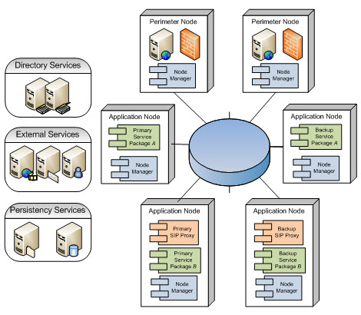

Each tenant is represented as a windows service running on an application server named Service Package. Each Service Package can be assigned to two nodes: once as a primary assignment and the second as a backup assignment. These definitions enable the node manager to select the appropriate application server that will provide service for a tenant.

For scalability purposes, a Geo Site is installed with numerous application servers which split the load for all the Geo site customers. All application server nodes are active and provide service. Each node executes the primary service package and at the same time serves as a backup node for other service packages. When a node is down, all executed services are relocated to other nodes which were configured as backup nodes for these service packages. All nodes work in partial load and there are no unoccupied servers.

Node Manager
The Node manager provides the following services:
- Node Management – building and maintaining a connected computer network and notifying other modules of network topology changes
- Service Management – managing the lifecycle of tenant service packages and other services (e.g. SIP Proxy) and notifying other modules of service statuses
- Configuration Management – providing access to configuration data, propagating configuration changes to all nodes and services and managing configuration changes concurrently
- Location Services – maintaining a table of available services with their location for quicker access to application services
- Information Provider – provides external systems with all the relevant data on current node, tenant and service statuses
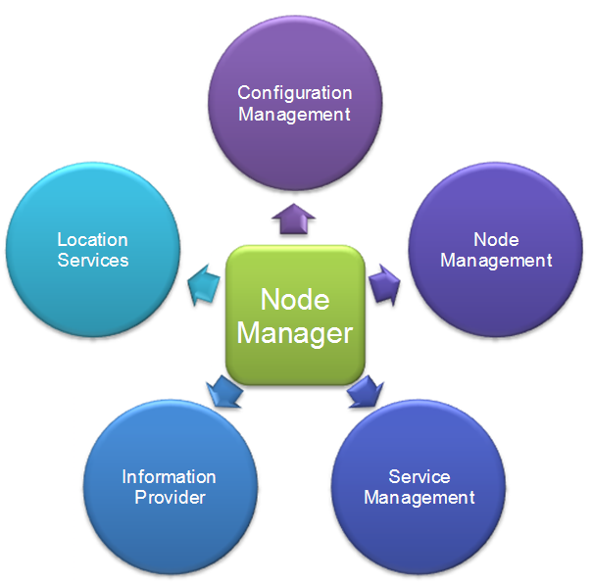
The Node manager is responsible for bootstrapping an organization’s service packages during system start. In addition, it also inspects each organization’s service packages and the state of other nodes. Furthermore, the Node Manager performs fail-over activities from primary to backup nodes and notifies external monitoring systems with the node and tenant service package states.
The Node manager provides API’s to be used by management tools. When one of the services reports problematic behavior (crashes or no ping response), the node manager activates the fail-over sequence.
The network of application nodes is built as a ring of connected node managers, while most information is shared between all the nodes. When a change in the network structure, configuration or services availability occurs, the Node manager issues a transaction token and transfers the relevant data to all nodes in the ring.

Perimeter Services
Perimeter Services are stateless services that use distributed operational data services and routing information to route the client’s request to a suitable service. The Perimeter services provide the demarcation of ECS’s clients’ application from the server components. It functions as the client authentication services. Furthermore, these services create a clear security boundary for ECS’s application servers while providing standard web service-based API’s, which allows clients to connect from any location over the Internet.
Perimeter Services are located in the DMZ network segment to provide maximum security. Each client request is authenticated and routed to the suitable application service.

SIP Proxy Services
SIP proxy services provide routing services for incoming telephony interactions. When a new organization (tenant) is activated for the first time or restarts, the application services register all its related telephony addresses and routes in the proxy to serve and route external and internal calls. SIP proxy redundancy is supported by using multiple computers with the same virtual IP known to both external services and ECS SaaS services.

Single Site Scalability and Operability

ECS’s Scalable Platform
ECS’s platform is based on a SaaS architecture that was designed to support multi-tenancy on a single platform. Each Contact Center organization that is configured on the platform is an additional tenant. All tenants are operated on standard Windows based servers while each server can hold multiple organizations according to its hardware capacity (CPU, Memory, Disk). Each tenant has its own metadata-based configuration that describes its operational behavior including IVR flows, routing strategies, agent’s profiles, parameters etc. Nevertheless, all tenants use the same platform software run time components and are operated on the same server as a separate process (Windows service) with a separate memory space.
ECS is designed to be a fully scalable platform with respect to the physical topology, meaning that numerous organizations can be operated on the platform scaling horizontally by adding additional standard servers.
ECS is also scalable in respect to the internal organizational structure - there are no limitations as to the number of contact centers per organization, business processes and channels per contact center, or agents per business process.
ECS’s platform is a Service Oriented Architecture (SOA) and is composed of numerous services that interact among themselves. Each service can be operated on a different node or on the same node according to the configuration. This distributed architecture contributes to the deployment flexibility of the product by enabling the operator to flexibly use its server’s inventory to operate ECS regardless of their model is, as long as they meet ECS’s prerequisite server specifications. The platform can be hosted on physical and virtual machines. ECS supports Microsoft Hypervisors and VMware.
The platform supports the following concepts:
Scale Out
The ECS platform uses the same software instance to operate all contact-centers tenants. Scaling out of the platform can be achieved using clustering or by splitting the workload over several different servers. That way, each server only needs to be powerful enough to handle partial load out of system’s overall volume. The Scale Out support is obtained by using ECS’s service-oriented architecture, meaning that each service can run on any server, which is part of ECS’s configuration. ECS’s SOA architecture was designed to support thousands of agents working simultaneously using a single platform serving numerous organizations.
Scale-Up
ECS can utilize more powerful servers as they become available to the market to support larger platforms with demanding processing power or to increase the number of contact centers hosted per server. ECS’s platform scale out and scale up capabilities enables selecting the most available, standard, cost-effective servers to lower the platform’s total cost, while stimulating return on investment.

Platform Administration
ECS’s platform includes the “configuration center for carrier admin”- a built in administrative tool for Evolve IP’s operational team. The configuration center is used to configure the platform by adding Nodes and Media Servers or modifying their attributes. In addition, the configuration center is used to create and deploy new organizations while configuring their attributes like Database and Email servers. Many of these functions have been built into OSSmosis for administration and provisioning, while super-user functions remain only in the Configuration Center.
ECS supports two types of services: Tenant Service Package or SIP Proxy. Each service can be configured and associated with two different nodes: Primary and Backup node.

Operability – Using the HA Monitor
ECS's High Availability Monitor is a graphical console that allows the NOC team to inspect the status of the tenants Service Packages or the SIP Proxy service, system nodes and the various service packages for each node in the ECS platform. Using ECS's High Availability Monitor the operational team can perform administrative actions to ensure the validity and consistency of the ECS system.

ECS Platform - Geo Redundancy and Scalability

Goals
ECS Geo redundancy and scalability architecture was designed with the following goals in mind:
- Build a carrier-class scale system capable of spanning any number of data centers over globally dispersed geographies
- Be able to serve any ECS customer from any (their closest) data center
- Be able to statefully fail over from one component to another, regardless of geography
- Be able to take components out of service for maintenance without disrupting services
- Achieve 99.999% service availability

Components
Single Geo Site Scope – An ECS Geo site is a standalone system that can serve numerous customers from a single data center. It includes the components described in previous sections:
- Perimeter Servers
- Application Servers
- Domain Controller
- SQL Server Cluster
- File Server
- Media Servers

Evolve IP Network - A Geo Site is accessed via Evolve IP’s global network components supporting voice and data, specifically:
Load Balancer which distributes the data traffic load hitting the Perimeter servers
SBC – VoIP Session Border Controller that provides Access and Peering voice path for ECS. Agents are using the Access path to register their softphones; The APP Servers are receiving and sending voice traffic via the Peering path.
Multi-site configuration – A layer in the ECS Carrier admin configuration center that adds multi-site parameters for the platform and for each tenant. The Carrier admin configuration center supports adding additional Geo sites and specifying the default Geo-site for each tenant. Most of the tenant configuration is identical regardless of the Geo Site it operates in. however, there are some site-specific parameters that should be used by the tenant run time service at a specific Geo Site, for example:
- Database host name
- SBC Access and Peering IP’s

Evolve Contact Control (ECC) – The ECC is a service that accesses the platform multi-site configuration and builds a view of all the system components in all Geo sites. It then communicates with each Geo Site Node manager to get the health status of every Geo site component and every tenant service. Based on the live data, the ECC will send alerts to the ECM (Evolve Contact Monitor). The ECC includes the ability to manually move tenants between Geo locations. In fact, it has the ability to select a new Geo Site for a tenant which can be different than the tenant default Geo Site as defined in the carrier admin configuration center.
In addition, The ECC can automatically initiate a failover sequence for one or more tenants. The ECC will post an alert message for the NOC team via the ECM and migrate tenants based on the current system health and availability.
Evolve Contact Monitor (ECM) – The ECM is a centralized web monitoring application that supervises the platform Geo sites and displays the operational data for all sites’ components and tenants. It is the main tool for the NOC team to monitor the system health and to receive timely alerts. This web application also supports functions like restarting a service or a node. It also enables the assignment of a tenant to another Geo Site.
Data Sync – ECS Geo Sites perform data synchronization in the background so that at any point in time, the critical data will be available in all Geo Sites. The following data items are synchronized continuously:
- Database – Operational tables are synchronized between sites
- Active Directory – All changes are synced between sites
- File Server – Configuration files are synchronized between sites

Note: Historical database tables and data warehouse tables are not synced between sites to reduce the data traffic bandwidth between sites. Reporting services will be available only from the assigned Geo Site. Same goes for the Recorded calls which will not be available in the secondary site.

Site Lookup Service
ECS Clients uses a URI for the initial activation of the client (Agent, Supervisor, SETUP). The URI is common to all Geo Sites and is hitting the Load Balancer which will render the web app from one of the Perimeter servers in one of the Geo locations (not necessarily the assigned Geo Site). Following a successful authentication, the client will query the Site Lookup Service, which is active on all Perimeter servers, and will receive the active Geo Site host name for this tenant. The Client will use this host for all future communications with the server. If the tenant will be assigned to a different Geo Site, the client will re-initiate the data communication by querying the Site Lookup Service and proceeding with the update host name.

Failover between Geo Sites
The ECS platform provides a two-level approach to service failover.
The first level is within a Geo Site. In cases of a single component failure within a site (App Server, Media Server, SQL Server, DC Server, Switch, VM host), the secondary components are engaged as they are designed to handle all the load required to operate all the site customers. There is no need to move a service outside a Geo Site if a single component fails.
In cases that a Geo site suffers a major issue which affects the ability of the site to provide service, then the ECC will detect such failure and initiate the failover sequence between sites for all tenants in the Failed Geo site. Since all the data is in sync between sites, the secondary Geo Site will start handling voice and data traffic for all moved tenants. Online clients will seamlessly begin to receive data and voice traffic from the secondary site.

ECS Platform Security
ECS’s architecture defines clear security boundaries between different clients and server components, providing a well-defined data separation between different tenants hosted on a single ECS platform.
The access to ECS’s services is protected by Perimeter services, which reside in the DMZ network segment and perform client authentication. Only authenticated clients can pass the DMZ to access server-side application services.
The security architecture is characterized by the following design concepts that were implemented in the product:

Authentication
Each tenant is delegated the responsibility of creating and maintaining its own user account, a process known as delegated administration in which the customer (tenant) is responsible for creating individual user accounts, while ECS authenticates them. This approach does not require any changes in a tenant's own user infrastructure.
The authentication architecture is based on a centralized authentication system using Microsoft Active Directory services, which serves all tenant applications. Each tenant is granted permissions to create, manage, and delete user accounts for his organization account on the user account directory. When users log into ECS, they are required to provide their credentials, which are then authenticated against the central directory. Following the user’s credential validation process, the system grants access permissions according to the user’s role. Password and security policies follow industry best practices regarding strength and lockouts.

Access Control
ECS’s architecture is designed to implement role-based authorization mechanism. A user in the system can be assigned to a role that defines a set of authorized functionalities, access rights and permission to perform actions. ECS’s design for roles is based on a simple mapping mechanism that enables modification of each role’s permitted functionality while enabling fast creation of new roles with a new set of permitted functionalities.
Client Applications - The client’s design is based on authentication and authorization mechanisms by creating a single client instance that looks and behaves differently for each user according to its role in the organization.
Scoping - ECS is designed to manage the access control at scope level. Each scope inherits roles, permissions, attributes and rules from its parent scope according to the applications sub systems and business hierarchy model.

Role Based Authorization
All ECS users are segmented into separate tenants, and for each ECS tenant a separate Organization Unit (OU) is defined using Microsoft Active directory. All tenant’s users are defined in this OU, providing full separation between different tenants.
When ECS's client application is accessed, a valid tenant user name and password must be provided. It will be authenticated against Microsoft Active directory and authorized for downloading the desired application, allowing data to be executed and accessed from the application.
To ensure user password security, ECS defines a default password policy, which can be adjusted by the tenants’ administrator to provide more granular policies for different user roles.
ECS implements a role-based authorization mechanism. There are three predefined roles for each tenant.
- Admin – This role provides customers with the ability to define business structure, business flows for interaction handling and other business-related rules and regulations.
- Supervisor – This role provides the ability to supervise business process activities including the agents that are connected and serving this business process. Furthermore, supervisors can perform several runtime configuration changes, to modify Business Process performance and staffing.
- Agent – This role enables users to handle ECS’s interactions.
Each user can be assigned to one or more roles and business process related roles. For example, a supervisor can be applied to more than one business process for the same user. User roles are checked for each request arriving at the server side and unauthorized requests are refused.

Client Security
CECS client applications are built on the Microsoft ClickOnce technology, providing the most comprehensive application deployment and execution security. The ClickOnce technology provides protection for the client machine at both install time and runtime, ensuring that the client machine and users can identify the publisher of the application (ECS). It also protects the application's files ensuring that no one can tamper with them after ECS's applications are published on the Web.
The ECS platform protects its client applications from being downloaded by unauthorized users by signing all downloaded applications. A clear mechanism is provided for tenant system administrators to identify the publisher of the downloaded application and avoid the possibility of tampering with ECS's client application code or phishing attacks.
In 2019, ECS will introduce a new web-based agent client application followed by a web-based Supervisor app. These apps will use ECS REST API and WebSocket based events subscription to communicate with the server.

Networking
ECS’s secured network architecture includes a multi-layered system protection. The multi-layered firewalls delineate multiple demilitarized zones (DMZ’s) both to protect data and restrict unauthorized access from all networks. All access to ECS applications and data are performed via the perimeter services, which perform user authentication and authorization.
Only authorized application or data segment users will be granted access. Any access to the ECS application is logged into security logs that can be analyzed to identify unwanted access or any other activity or attack attempt.
ECS uses WCF transport security to assure mutual client/server authentication and message protection. Mutual authentication involves authenticating both the message sender and receiver, to prevent possible man-in-the-middle attacks. Communication messages are digitally signed to ensure message integrity and are encrypted to provide confidentiality.
All ECS server-to-server communications are performed on TCP/IP protocols with NetTcpBinding protocol on top.
Data transmission between the tenant and ECS perimeter servers are secured with industry standard Secure Sockets Layer (SSL) protocol, which allows the client application to communicate with ECS perimeter services in a way that is designed to prevent eavesdropping, tampering, and message forgery.

Confidentiality and Data Security
To provide full confidentiality for ECS tenants, each tenant is separated from the other on two levels: runtime address space separation and data store separation. Each tenant request is executed in a private tenant’s address space (separate process) thus preventing different tenant requests to be processed together. Furthermore, all tenants’ data is stored in a separate Database instance, for both tenant configuration definitions, historical, reporting and operational data.
System operational data is also stored separately from other tenants. System data has neither historical reporting nor operational data but does have system configuration data.
Tenant’s users can access data segments according to their role in several authorization modes: Unauthorized to View, view only and Edit for update. Recorded files are stored separately per tenant in a separate folder and can be accessed only by authorized users from a specific tenant.

Auditing
ECS detailed logging mechanism provides audit trail using log files, which includes comprehensive information of all activities and users. All logged information is stored in well-structured XML files and can be automatically transferred to a centralized location for automatic activities validation. Log analysis tools are provided with ECS’s system.

Timeline
- At the present, ECS is serving its customers from a single data center located in Las Vegas.
- A second data center located in Philadelphia is being setup and is planned to be operational as an additional single Geo site in Q2/2019
- The described functionality for the Geo redundancy is planned to be released in Q3/2019 operating the two Geo sites as a unified platform

