ECS Support Handoff
Call Flow
Please refer to the call flow visio. This will provide a high level view of our customer’s interaction with ECS during an inbound call. The call flow has been stable since inception and hasn't undergone any drastic changes. Therefor only an understanding of flow will be needed for now. If you have any questions please let me know.
- Business Processes (7 in Production)
- UCaaS (Triage)
- Cloud (Triage)
- ITaaS (Triage)
- Vetanium (Triage & Vet Enterprise customers)
- Client Tech (Overflow after 5 minutes in Triage)
- Enterprise (Subset of agents only fielding Enterprise calls)
- Carrier (Subset of agents only handling alarms)

- Demands/Skills (4 in Production)
- UCaaS
- Cloud
- ITaaS
- Vetanium

- Channels (12 in Production)
- Channel - (Top Level - Directs to Main Flow, Carrier BP or Chat (coming soon))
- Main Flow - This is where the data dip occurs where it will either match the number and send to services channel or to number confirm if no match is found or if caller is identified as private label/agent.
- Number Confirm - Customer/Private Label/Agent will be prompted to enter their account number if not known they will be sent to the Catch All Channel.
- Catch All - This channel is a menu where the customer will select option 1 through 4 for services. (UCaaS, Cloud, ITaaS & Vetanium). From here they will be sent to the Ticket Entry Channel.
- Services and Services 2 - This is where customers are sent when they call from a matching number (Main Flow Channel) or enter in a matching account number (Number Confirm Channel). This will check the respective record for Yes/No values for the 4 product sets. Based on these yes/no values customers will receive a custom menu to the products they have designated by Yes values in the CRM. When the selection is made for a product a demand will be set and the caller will be passed to the Ticket Entry Channel. If a customer only has one product set the demand will automatically be set and caller passed to Ticket Entry Channel.
- Ticket Entry - Now that we know what product set the customer is calling about we will ask if they have an existing ticket or new issue. If they select existing ticket we will prompt them for their 6 digit ticket number. Once confirmed we will then pass the caller to the correct business process based on the earlier product set demand. One exception here would be before passing we will check to see if this is an Enterprise customer (designated by Yes value in Enterprise CRM field). If they are marked as an enterprise customer they will still have the product set demand but instead be passed to the Enterprise Business Process. If the caller does not have an existing ticket then this will be deemed a new issue and the call will forward to the Submenu Channel.
- Submenu - This channel will simply check the current demand of the call and pass to the particular product set submenu.
- Product Set Submenu (4 total, 1 for each product) - Based on the demand the previous Submenu Channel will direct here. This is where the caller will select the reason for their call. Visio will display the list of options the caller can have. Once they make their selection the caller will then be forwarded to the correct product based business process. One exception here would be before passing we will check to see if this is an Enterprise customer (designated by Yes value in Enterprise CRM field). If they are marked as an enterprise customer they will still have the product set demand but instead be passed to the Enterprise Business Process.
Number Additions
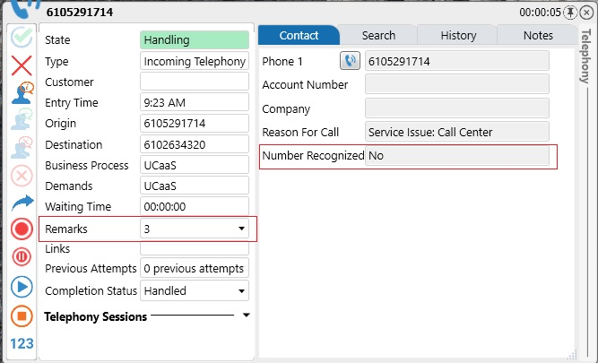
Number additions will be indicated via the call flow and also via screen pop to the agents.
When receiving a call from ECS it will now display if the system was able to recognize the incoming number based on CRM records. If the number did not receive a match you will see a “No” value in the pop-up. If this occurs please open the remarks section highlighted below which will tell you what to do.

As you can see the remarks section tells you to obtain the company name and email to rcannon@evolveip.net. I will contact helpdesk to have this become a distribution list and modify the remark.
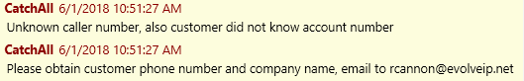
So in this case the agent would email the following. Call from 6105291714 Company: Evolve IP
Based on this provided information you can now begin the associating that provided number to a company and their particular product set.
Below is an example of a correctly recognized number.
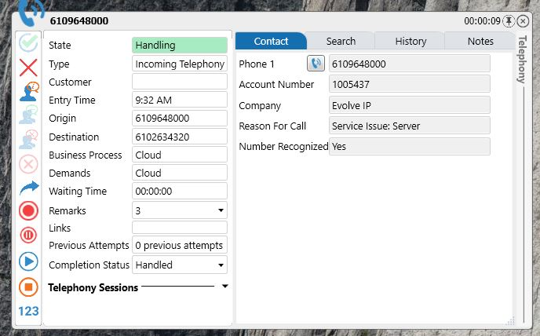
Now that we have been provided a number we will now have to add this number to the system via the supervisor client. There are two files needed to accomplish this, both located on the G Drive.
G:\Evolve Contact Suite\Contact_Adds.csv
This is a template to use when adding new numbers. Save this to your desktop to modify.
G:\Evolve Contact Suite\Company_List.xls
This is the list of companies currently in the system and their associated services. Please do not save any changes to this document unless fully verified.

- Take the number that was provided to you by Support.
- Place that in the phone number column of ContactAdd.csv
- Refer to the CompanyList.csv and copy paste the into ContactAdd.csv
- Your final version should reflect the below.
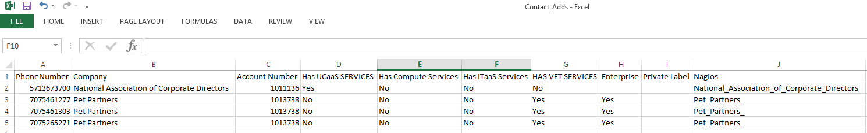
  - Private Labels and Agents that manage multiple client will have a Yes in the private label column.

Now you are ready for the upload within ECS Supervisor.
- Navigate to the Contacts tab at the top.
  - 
- Select the Import tab on the Contacts Monitor.
  - 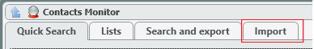
- Select the Import Contacts Wizard
- Navigate to your saved ContactsAdd.csv
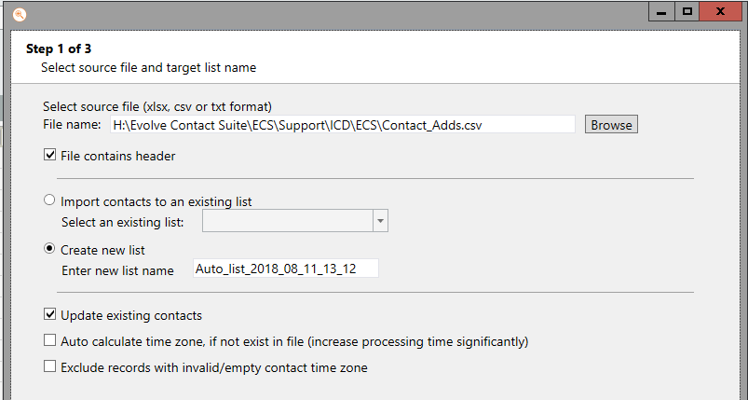
  - Use the following settings, Select Next.
- Use the ICD Template, Select next and confirm the upload.
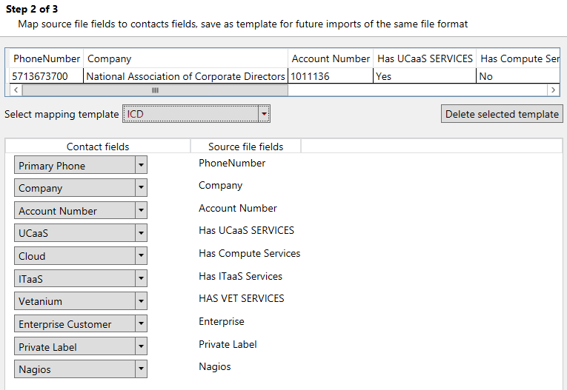

The contacts are now uploaded and on their next call into the system they will be associated with the uploaded product sets (Yes/No values)
Reporting Trace
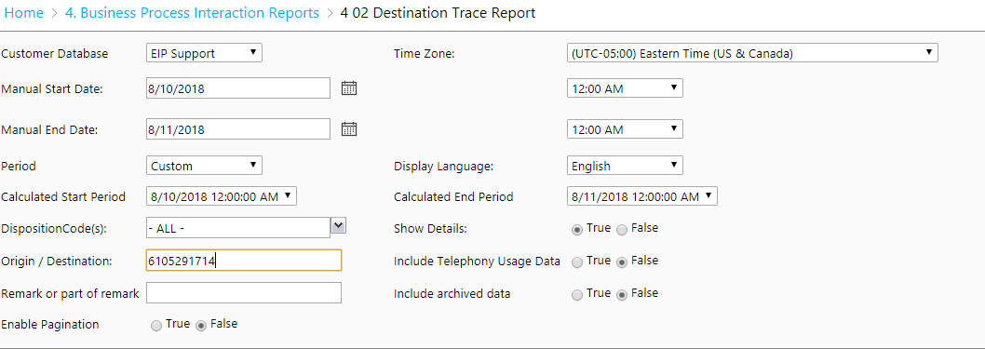
A helpful tool in troubleshooting call examples is the 4.0.2 Destination Trace Report. This can be accessed via the ECS Support URL Analytics section. A supervisor/admin login is needed to access this section. Once you login navigate to the referenced report and populate the data elements and select View Report.
Here you can see any time the number called into the system, the output will look something like this. The information provided here will help assist in troubleshooting or investigating certain call paths.
